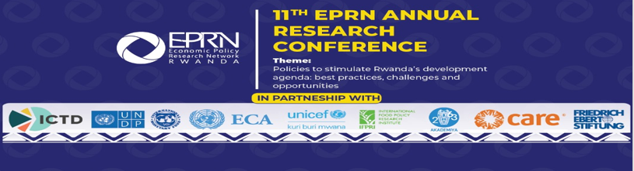

Conference Report
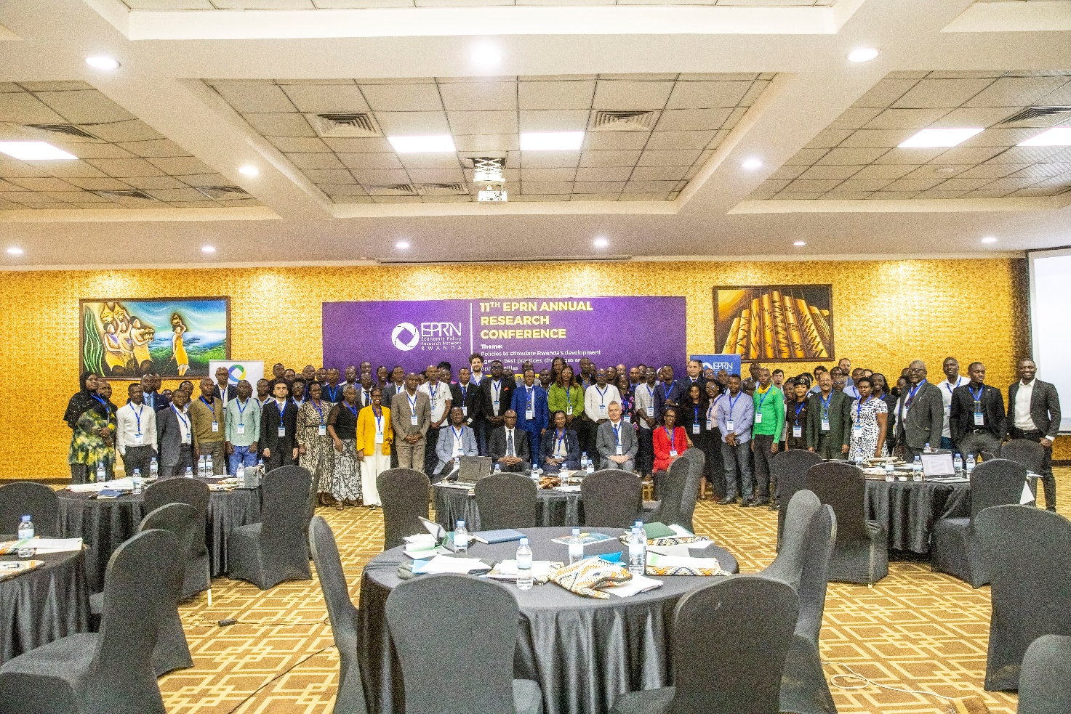

Dates: 26th to 27th June 2025
Venue: Lemigo Hotel - Kigali
Rwanda
Table of Contents
LIST OF ABBREVIATIONS 3
1. Introduction 4
2. About the 10th Economic Research Conference 5
3. Conference highlights 5
3.1. Welcome and opening remarks 5
3.2. Conference Proceedings 9
3.2.1. Session 1: Enhancing resilience of economies in this era of socio- economic shocks 9
3.2.2. Session 2: Domestic Revenue Mobilization through effective tax policy administration 14
3.2.3. Session 3: Youth in agribusiness, challenges and opportunities 20
3.2.4. Session 4: Gender policies: What is already there? What is missing? How can we enforce them? 23
4. Conference Recommendations 27
5. Closing remarks 28
ANNEX 1: CONFERENCE AGENDA 29
ANNEX 2: BIOGRAPHIES OF SPEAKERS 1

Gallery of Photos

Photo 1: Photo: Mr. Fabrizio Santoro delivering key note speech 7
Photo 2: Ms Stella NTEZIRYAYO, opening the Conference 8
Photo 3: Photo: Some participants of the 11th EPRN Research Conference 9
Photo 4: Dr. Andrew Mold, EPRN Board Member, and researcher at the UNECA 9
Photo 5: Dr Ostein Chulu, UNDP Rwanda 12
Photo 6: The 1st panel discussion 13
Photo 7: Dr. Fabrizio Santoro, ICTD 15
Photo 8: Mr. Abel Ntegano, MINECOFIN 16
Photo 9: Photo: Dr. Jean Paul MPAKANIYE, EPRN and INES 17
Photo 10: Photo: The 2nd panel discussion 18
Photo 11: Four young entrepreneurs presenting their experiences and testimonies in agribusiness. 20
Photo 12: 3rd panel discussion 22
Photo 13: 4th panel discussion 24
Photo 14: Prof Birasa Nyamulinda, EPRN 26

LIST OF ABBREVIATIONS

AGRA Alliance for a Green Revolution in Africa
CARE Cooperative Alliance for Relief and Emergency
EPRN Economic Policy Research Network
FES Friedrich-Ebert-Stiftung
FWG Feminist Working Group
GDP Gross Domestic Product
ICTD International Centre for Tax and Development
IMF International Monetary Fund
EICV Integrated Household Living Conditions Survey
ICTD International Centre for Tax and Development
MINAGRI Ministry of Agriculture and Animal Resources
MINECOFIN Ministry of Finance and Economic Planning
NST National Strategy for Transformation
RRA Rwanda Revenue Authority
UNICEF United Nations Children's Fund
UNDP United Nations Development Program
UNECA United Nations Economic Commission for Africa

Introduction

Rwanda aspires to become a Middle-Income Country by 2035 and a High-Income Country by 2050. Specifically, this means that the GDP per capita will be over USD 4,036 by 2035 and over USD 12,476 by 2050. This will also be achieved through ensuring all walks of society have increased opportunities to contribute to national development, including by growing investments in human capital and ensuring universal access to amenities, safety and security. All youth, women, men, people with disabilities and elderly people will contribute as actors of sustainable development, ensuring that no one is left behind in benefiting from development.
Rwanda's economy continued to stage a strong growth in the first half of 2024. After growing by an average of 8.2% in 2022-2023, real GDP increased by 9.7% in the first half of 2024. GDP growth is expected to maintain momentum in 2025–26, with a projected average of 7.7%, thanks to a recovery in global tourism, new construction projects, and manufacturing activities. During the first National Strategy for Transformation (NST1), Rwanda made remarkable progress whereby over 1.37 million jobs were created between 2017 and 2023. Exports grew at an average annual rate of 21%, with revenue more than doubling by 137% from 2017 to 2023, driven by the "Made in Rwanda" initiative.
The overall fiscal deficit declined from 7.7% of GDP in 2022 to 7.0% in 2023 due to improved domestic resource mobilization. The debt-to-GDP ratio declined from 71.3% in 2022 to 66.6% in 2023 due to budget rationalization. The current account deficit averaged 10.7% of GDP in 2022 and 2023 because of the high import bill.

Despite remarkable growth performance in recent years, creation of jobs in Rwanda is insufficient and the level of productivity remains low, reflecting infrastructure gaps, limited progress in innovation, and sub- optimal allocative efficiency. Furthermore, the inclusiveness of growth remains a key challenge, as the poverty reduction momentum has weakened in recent years. The benefits of structural transformation have tended to accrue to more educated workers, worsening inequality. Vulnerability to climate change, and the increasing pressure on natural resources are also among key challenges to be tackled.
The Rwandan government approved the second National Strategy for Transformation (NST2), a comprehensive and forward-looking five-year plan that will run until the end of 2029. Approved on August 23, this strategy charts a bold new course for Rwanda's continued development. NST2 seeks to further advance the progress made under the previous strategy, NST1. It is designed to lay a strong foundation for sustained growth, bringing Rwanda closer to achieving higher living standards for all.
The seventh Integrated Household Living Conditions Survey (EICV 7), which shows significant improvement in citizens’ well-being—including the lifting of over 1.5 million people out of poverty over the last seven years.
To keep growing its economy towards Vision 2050 targets, Rwanda needs to transform the structure of its economy to respond to current challenges and opportunities driven by technological progress and climate change. Furthermore, Rwanda has to overcome the limits of its small domestic market and landlocked position and find its place in global and regional value chains. There is also need for greater reliance on private sector investment to enhance productivity growth, raise incomes, enhance its human capital, modernize agriculture and provide the financing to address infrastructure shortfalls.

About the 11th Economic Research Conference
In line with the above emerging developments and policy initiatives, the Economic Policy Research Network and partners organized the 11th Economic Research Conference under the following theme: “Policies to stimulate Rwanda’s development agenda: progress, challenges and opportunities”.
This high-level and interactive 2-day research conference brought together more than 200 participants, including researchers, senior policymakers, representatives of the development partners, civil society, private sector and the media. During the conference, research papers and reports related to conference sub-themes were presented and discussed. Policy recommendations were formulated and shared with concerned institutions as a contribution towards boosting Rwanda’s economic resilience during the current socio-economic shocks.
In addition to the presentations; 4 high level panel discussions were organized and actualized:
- Enhancing resilience of economies in this era of socio- economic shocks (sponsored by UNDP)
- Domestic Revenue Mobilization through effective tax policy administration (sponsored by ICTD)
- Youth in agribusiness, challenges and opportunities (sponsored by AKADEMIYA2063)
- Gender policies: What is already there? What is missing? How can we enforce them? (sponsored by FES and UNICEF)
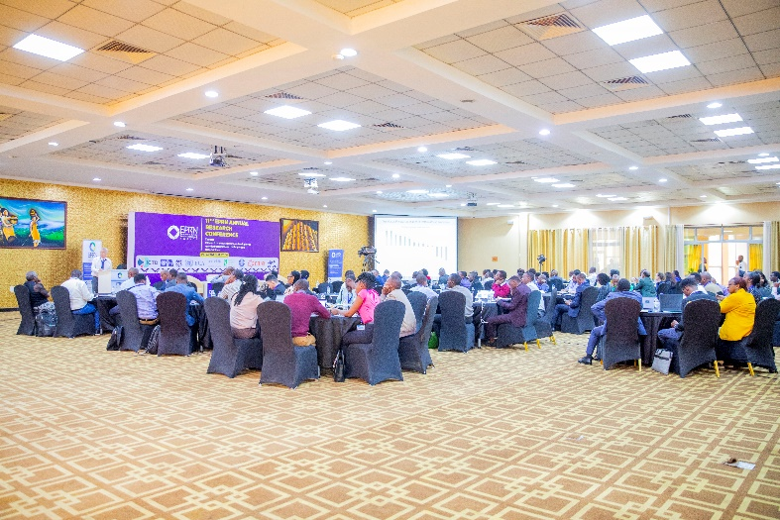
Photo 1: Participants in the 11th Annual Economic Research Conference

Conference highlights

Welcome and opening remarks

Welcome remarks by Prof. Kasai Ndahiriwe, EPRN Vice-Chairperson
At the 11th EPRN Annual Research Conference, held at Lemigo Hotel from June 26th to 27th, 2025, the Deputy Chairperson of EPRN, Prof. Kasai Ndahiriwe, delivered the welcome remarks. He began by extending a warm welcome and expressing gratitude to all attendees, including government officials, representatives from international organizations such as ICTD, UNDP, UNICEF, AKADEMIYA 2063, IFPRI, UNECA, EPRN Board Members, researchers, members, friends of EPRN, and participants joining both in person and online.

Prof. Ndahiriwe highlighted the role of the Economic Policy Research Network (EPRN Rwanda) as a research and training centre dedicated to advancing evidence-based economic policymaking. He emphasized that EPRN achieves its mission through high-quality research, capacity building, and networking opportunities for local experts, with annual research conferences being a key activity.

This year’s conference was centered on the theme “Policies to stimulate Rwanda’s development agenda: best practices, challenges and opportunities.” The presence of diverse stakeholders at the event was noted as a testament to the collective commitment to bridging the gap between research and policy development. Prof. Ndahiriwe expressed appreciation for the participants’ attendance, which underscored the importance of connecting research with effective policy formulation.

He addressed the profound and far-reaching socio-economic impacts of major shocks, including the COVID-19 pandemic, geopolitical conflicts, and climate change, on livelihoods and economies. These shocks have led to immediate economic hardships, prompting governments to introduce ambitious anti-recession measures. Prof. Ndahiriwe stressed the importance of minimizing risks associated with such shocks and strengthening economic resilience through policies that both mitigate risks and address the consequences of severe crises. He discussed the need for effective monitoring of domestic vulnerabilities and the establishment of proactive policy mechanisms to absorb the impact of economic downturns.

Crucially, Prof. Ndahiriwe pointed out the importance of balancing the benefits and costs of these policies, particularly regarding their potential impact on economic growth. He noted that when risk-mitigating measures involve trade-offs with growth, it is essential to identify the most cost-effective actions that encompass both macroeconomic and structural policies.
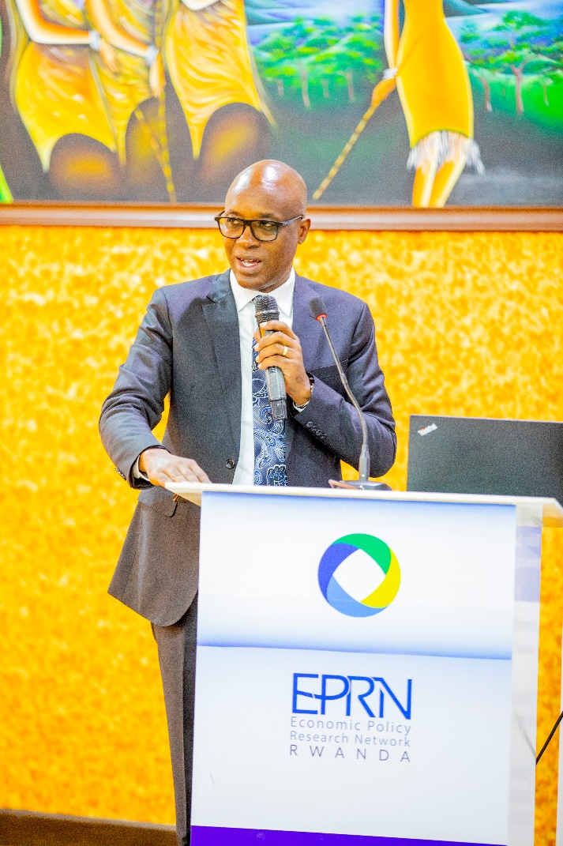
During the conference, participants would have the opportunity to brainstorm on research findings and engage in panel discussions to analyze the magnitude of these shocks and propose policy recommendations for the government and other stakeholders. Prof. Ndahiriwe remarked that the success and pace of recovery would depend on the strength and effectiveness of the policies implemented during the crisis, and that economic research plays a crucial role in analyzing the consequences of the current crisis, adopting a comparative-historical approach to previous economic downturns.

He concluded by expressing sincere gratitude to all partners who provided technical and financial support for the conference, including ICTD, UNDP, UNECA, AKADEMIYA 2063, and UNICEF. Prof. Ndahiriwe acknowledged the EPRN Secretariat for their exceptional organization of the event and extended thanks to all participants for honoring the invitation and dedicating their time to the conference. He closed his remarks with heartfelt appreciation and best wishes to all involved
Photo 2: Prof Kasai Ndahiriwe, deputy chairperson, giving welcome remarks

Key Note Address by Mr. Fabrizio Santoro, a research fellow at the International Centre for Tax and Development (ICTD)
Mr. Fabrizio Santoro, a research fellow at the ICTD, delivered a compelling speech that captured both the progress Rwanda has made and the challenges that remain on its path to sustainable development. Having worked in Rwanda over the past eight years, Santoro began by expressing his admiration for the country’s remarkable transformation, visible not only in its infrastructure and services but also in the ambition and resilience of its people. “It is truly a pleasure to be back in Rwanda,” he said, noting that each visit reveals new evidence of progress and determination.
Representing ICTD, and conveying regards from Executive Director Giulia Mascagni who could not attend, Santoro thanked EPRN for organizing the event and inviting ICTD to contribute to this important dialogue. He emphasized the significance of the conference theme: “Policies to stimulate Rwanda’s development agenda: best practices, challenges and opportunities.” According to Santoro, this theme is timely and essential, as Rwanda strives to become a Middle-Income Country by 2035 and a High-Income Country by 2050.
Achieving these ambitious goals, he said, will demand much more than strategic policy reforms and investment; it will also critically depend on effective and equitable domestic resource mobilization — specifically, building tax systems capable of funding Rwanda’s development vision sustainably.
Highlighting ICTD’s mission, Santoro shared how the organization works to produce high-quality, policy-relevant research to support stronger tax systems across Africa. He pointed to ICTD’s decade-long partnership with the Rwanda Revenue Authority (RRA) as an example of research directly informing policy. “We believe that evidence matters — that better research can lead to better policy, and ultimately, better development outcomes,” he said.
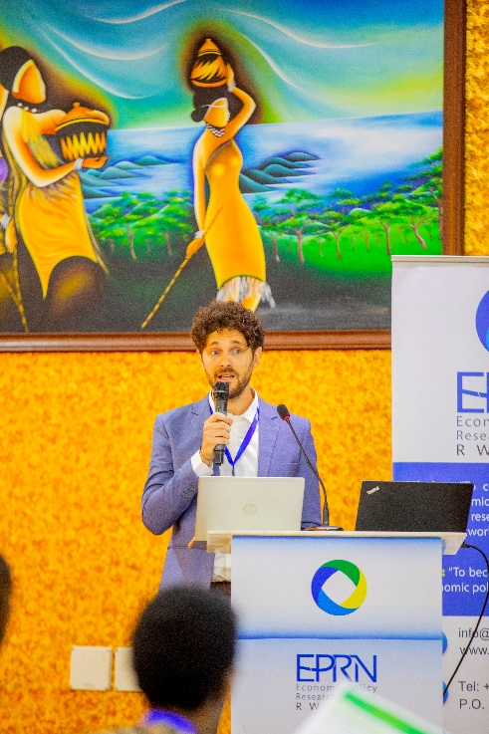
Santoro also addressed the broader role of taxation beyond revenue collection. Properly designed and administered tax systems, he argued, can reduce inequality, enable public investments, and reinforce the social contract between citizens and the state. In an era of global uncertainty, climate change, and economic transformation, resilient and inclusive tax systems are more important than ever.
Importantly, he underscored ICTD’s philosophy that research must inform reform. Santoro called for greater dialogue between researchers and policymakers, more data-driven analysis, and the creation of forums — like this conference — where knowledge, innovation, and practical solutions come together to advance Rwanda’s development goals.
Closing his remarks, Santoro wished the participants productive discussions over the coming days, expressing eagerness to hear from Rwanda’s experts and share in their experiences. He reaffirmed ICTD’s commitment to supporting Rwanda’s journey toward inclusive and sustainable growth.
“Thank you for the opportunity to contribute, and thank you for your continued commitment to building a stronger, more inclusive Rwanda,” he concluded.
Photo 3: Photo: Mr. Fabrizio Santoro delivering key note speech

Opening Remarks by the Guest of Honor, Ms. Stella NTEZIRYAYO, Chief Economist, Ministry of Finance and Economic Planning.


The Guest of Honor delivered remarks that set the tone for the event’s focus on “Policies to Stimulate Rwanda’s Development Agenda: Best Practices, Challenges, and Opportunities.” The Guest of Honor began by expressing sincere gratitude to EPRN, its partners, and all contributors for sustaining this crucial platform for dialogue, research, and policy engagement. The timeliness of the conference theme was emphasized, particularly as Rwanda pursues its ambitious Vision 2050 and the National Strategy for Transformation (NST2).

A central message of the remarks was the importance of evidence-based policymaking. The Guest of Honor highlighted that Rwanda’s notable achievements in health, education, infrastructure, and financial inclusion have been the result of bold, research-informed policy decisions and ongoing stakeholder engagement. The recent Integrated Household Living Conditions Survey (EICV 7) was cited as evidence of progress, with over 1.5 million people lifted out of poverty in the past seven years.
Photo 4: Ms Stella NTEZIRYAYO, opening the Conference

However, the remarks also acknowledged that as Rwanda’s development context evolves, new and complex challenges have emerged. These include ensuring inclusive growth that benefits all Rwandans, securing sustainable financing for development amid global uncertainties, leveraging technology and innovation to create jobs and boost productivity, and building resilience to climate change and external shocks. The Guest of Honor stressed that addressing these challenges requires rigorous analysis, locally grounded evidence, and the adaptation of international best practices to Rwanda’s unique context, underscoring the critical role of the conference and its participants.

Looking ahead, the Guest of Honor outlined the need for Rwanda to structurally transform its economy to meet Vision 2050 targets. This transformation involves adapting to technological advancements and climate realities, overcoming the constraints of a small domestic market and landlocked geography, and integrating more deeply into global and regional value chains. The remarks also called for greater reliance on private sector investment to drive productivity, enhance incomes, modernize agriculture, and finance infrastructure needs.

The Ministry of Finance and Economic Planning’s commitment to responsive, data-driven, and transparent public policy was reaffirmed, with examples such as program-based budgeting, performance contracts (Imihigo), and results-based management. The Guest of Honor encouraged continued collaboration between government, academia, civil society, and the private sector to strengthen Rwanda’s economic policy research ecosystem. This includes investing in young researchers, supporting policy-relevant studies, and fostering ongoing dialogue through platforms like the EPRN conference.

The Guest of Honor commended EPRN for its leadership and contributions to Rwanda’s policy landscape, urging that the conference serve as a call to action for generating knowledge, challenging assumptions, and building a more prosperous and equitable Rwanda. The conference was officially declared open, with best wishes extended for productive discussions and impactful outcomes.

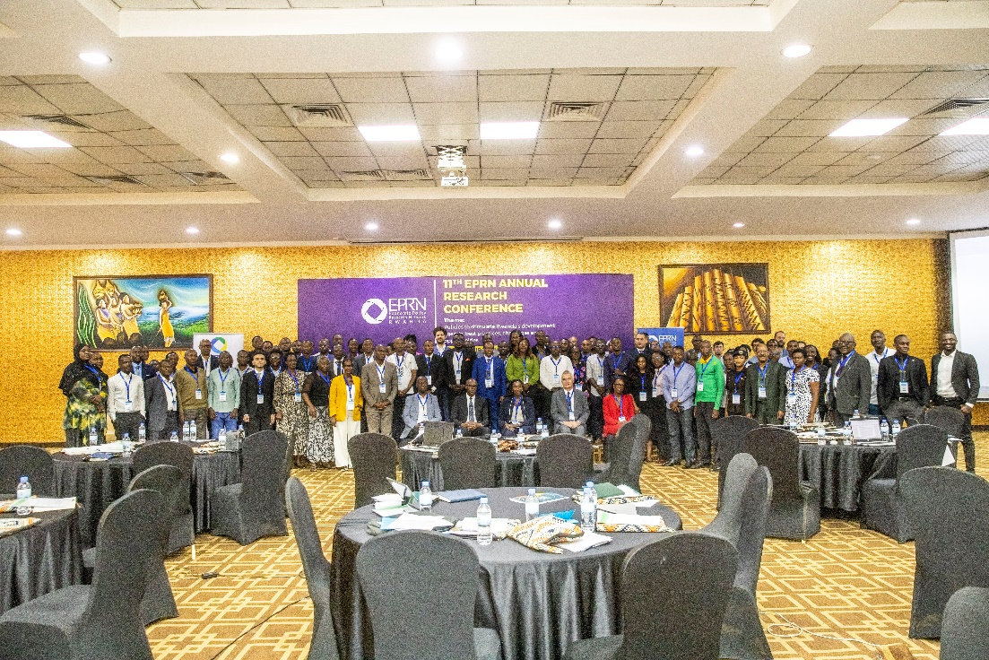
Photo 5: Photo: Some participants of the 11th EPRN Research Conference

Conference Proceedings

DAY 1: 26th June 2025

Session 1: Enhancing resilience of economies in this era of socio- economic shocks
The first presentation was delivered by Dr. Andrew Mold and was about Rwanda’s Developmental Agenda and Challenges in a Regional Context – What’s Next?

Dr. Andrew Mold’s presentation, delivered at the 11th EPRN Conference, offers a comprehensive overview of Rwanda’s recent macroeconomic performance, its developmental priorities and the broader regional context within Eastern Africa.
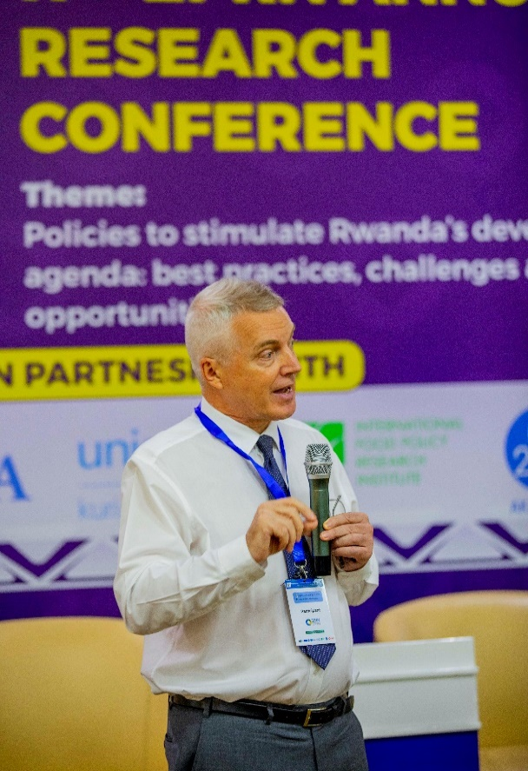
Key Points
- Macroeconomic Overview; Eastern Africa has demonstrated notable economic resilience despite recent global and regional shocks. Rwanda’s GDP growth in 2024 was primarily driven by robust performance in the trade and transport sectors, with these industries leading quarterly growth throughout the year. Inflation across the region has eased but remains uneven, with Rwanda maintaining inflation within the National Bank of Rwanda’s target range of 2–8%. In 2024, annual headline inflation in Rwanda averaged 4.8%, a significant drop from 14% in 2023, largely due to improved agricultural output and the effects of earlier monetary policy tightening. However, the local food price index reveals ongoing vulnerabilities, particularly in the face of external shocks.

Export growth in Eastern Africa has outpaced import growth, a positive sign for regional economies. Fiscal adjustments have been challenging in some countries, with several experiencing harsh fiscal tightening. Debt servicing remains a concern, especially for Kenya and Uganda, where interest payments consume over 20% of government revenue. The US dollar weakened notably in early 2025, reflecting shifts in global monetary policy expectations.
Photo 6: Dr. Andrew Mold, EPRN Board Member, and researcher at the UNECA

- National Budgets and Development Priorities; The 2025/2026 government budgets across East Africa reflect diverse priorities. Rwanda’s budget saw a 21% increase from the previous year, with significant allocations to infrastructure (notably the Bugesera International Airport), agriculture, electrification, education, healthcare, and housing. These priorities are closely aligned with Rwanda’s National Strategy for Transformation (NST-2), emphasizing inclusive growth and structural transformation.

- Food Security in Eastern Africa; Food security remains a pressing issue, with the number of undernourished people in Africa continuing to rise. International food prices have increased markedly, but Africa is not the world’s largest net food importer. The region’s food production cycles are poorly synchronized, resulting in weak correlations in agricultural GDP growth among East African Community (EAC) countries. This asynchrony suggests significant potential gains from enhanced intra-regional trade, which could help stabilize food supplies and reduce price volatility.

Econometric analysis indicates that existing African regional trade agreements (RTAs) have modestly increased intra-regional agricultural exports by about 15%. Meta-analyses suggest that regional blocs can boost bilateral trade by up to 32%. The African Continental Free Trade Area (AfCFTA), once fully implemented, is projected to have a much larger impact, potentially increasing intra-African agri-food trade by around 60% by 2045.

- Foundations for Sustained Economic Growth; The presentation highlights three key preconditions for long-term economic diversification and growth, based on Robertson’s (2022) framework: demographic transition, access to affordable and reliable electricity, and education—particularly mass literacy. Rwanda and its neighbors have experienced varying growth trajectories despite similar starting points, with Vietnam’s rapid increase in electricity consumption cited as a benchmark for transformative growth.

Financial sector dynamics remain a challenge, with high central bank and lending rates constraining private sector credit. Domestic credit to GDP ratios in the region lag behind global averages, underscoring the need for deeper financial sector development.

Implications
- Economic Resilience Amid Global and Regional Shocks; Rwanda and Eastern Africa have demonstrated robust economic resilience, with Rwanda’s GDP growth in 2024 driven by trade and transport, despite facing global uncertainties and regional shocks.

Inflation management has improved, with Rwanda maintaining inflation within the National Bank’s target range, and a significant reduction in headline inflation from 14% in 2023 to 4.8% in 2024, largely due to better agricultural output and effective monetary policy.

- Fiscal and Debt Pressures; Fiscal adjustments have been severe in some countries, with high debt servicing costs, particularly in Kenya and Uganda, where interest payments exceed 20% of government revenue. Rwanda’s increased budget (up 21%) signals a commitment to development, but also highlights the need for prudent fiscal management to avoid future debt sustainability issues.

- Strategic Development Priorities; Rwanda’s budget allocations align with its National Strategy for Transformation (NST-2), prioritizing infrastructure (notably Bugesera International Airport), agriculture, electrification, education, healthcare, and housing. These priorities reflect a focus on inclusive growth and structural transformation, aiming to accelerate job creation, boost exports, and enhance public service delivery.

- Persistent Food Security Challenges; Food insecurity remains a significant concern in Eastern Africa, with the number of undernourished people rising and international food prices increasing. Poor synchronization of food production cycles across the region suggests that stronger intra-regional trade could stabilize food supplies and reduce price volatility, benefiting both producers and consumers.

- Regional Integration and Trade; Existing African regional trade agreements have had a modest positive impact, increasing intra-regional agricultural exports by about 15%. The African Continental Free Trade Area (AfCFTA) is projected to be transformative, potentially increasing intra-African agri-food trade by around 60% by 2045, highlighting the importance of leveraging continental markets for economic growth.

- Foundations for Long-Term Growth; Three core preconditions for sustained economic diversification and growth are emphasized:
- Demographic transition;
- Access to affordable and reliable electricity; and
- Mass literacy and quality education.

Rwanda and its neighbors have experienced divergent growth trajectories, with Vietnam’s rapid development cited as an example of the transformative potential of increased electricity consumption and investment in human capital.

- Financial Sector Constraints; High central bank and lending rates constrain private sector credit, limiting investment and economic expansion. Domestic credit to GDP ratios in the region are low, underscoring the need for deeper financial sector development to support growth.

- Strategic Outlook; Rwanda’s continued resilience and clear developmental agenda position it well for future transformation, but success will depend on accelerating job creation, improving education, and fostering export growth. Regional integration and trade are critical levers for mitigating external shocks, stabilizing food supplies, and unlocking new growth opportunities.

These implications underscore the need for sustained policy focus on fiscal discipline, human capital development, infrastructure investment, and deeper regional integration to ensure long-term, inclusive growth for Rwanda and the broader Eastern African region

Conclusions
Rwanda is navigating fiscal pressures with resilience, underpinned by solid macroeconomic fundamentals and a clear developmental agenda. The country’s next phase of transformation, as outlined in NST-2, will require accelerated job creation, export growth, improved education quality, and enhanced public service delivery. In the face of global uncertainties, leveraging the continental market through regional integration and trade remains a strategic imperative for Rwanda and its neighbors.

The 2nd presentation was delivered by Dr. Osten Chulu and was about Green Financing for sustainable development and resilience
Dr. Osten Chulu’s presentation at the EPRN Conference 2025 explores the critical role of green financing in advancing Rwanda’s sustainable development and resilience objectives, particularly in the context of climate vulnerability and ambitious national targets.
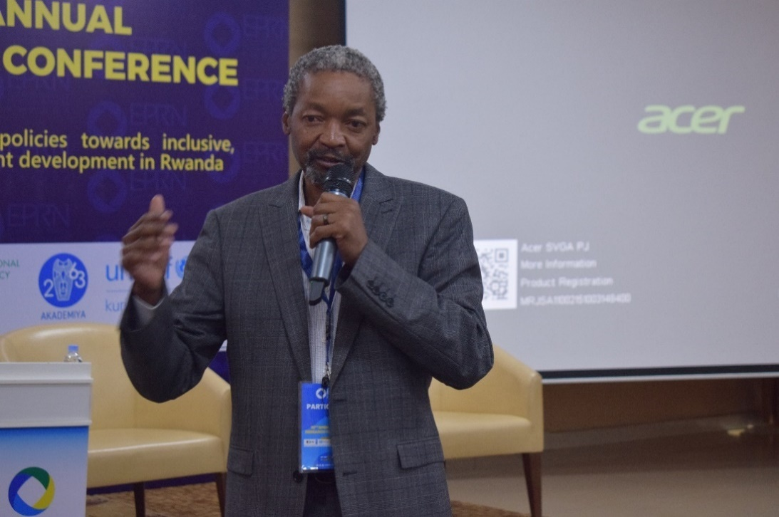
Key Points
Rwanda faces acute climate risks, with projections of a 2.5°C temperature rise by 2050 and 70% of its workforce engaged in climate-sensitive sectors such as agriculture, water, and energy. Achieving the country’s Nationally Determined Contributions (NDCs) by 2030 will require an estimated USD 11 billion, underscoring the centrality of green finance to Rwanda’s Vision 2050 and National Strategy for Transformation (NST 2). Green finance encompasses a broad array of financial instruments, including loans, insurance, stocks,
Photo 7: Dr Ostein Chulu, UNDP Rwanda
private equity, and bonds, channeled towards eco-friendly projects. The concept has evolved from simple public sector funding in the 19th century to a diverse ecosystem involving public, philanthropic, and increasingly private sector investment, with innovative mechanisms such as social policy bonds and crowdsourcing platforms.

Rwanda’s policy and institutional landscape is robust, anchored by the Revised Green Growth and Climate Resilience Strategy, a Green Taxonomy defining eligible investments, and a Sustainable Finance Roadmap guiding ESG-aligned capital flows. The establishment of a Climate Finance Unit within the Ministry of Finance further institutionalizes these efforts.

The country’s experience with green financing is notable. The Rwanda Green Fund (FONERWA) has financed over 40 projects, mobilizing more than USD 200 million, creating over 137,000 green jobs, reducing CO2 emissions, and restoring ecosystems. Notably, the Development Bank of Rwanda (BRD) issued East Africa’s first Sustainability-Linked Bond (SLB) in 2023, raising USD 124 million with key performance indicators tied to gender inclusion, ESG, green housing, and MSME access. A second SLB is under development, and the Climate & Nature Finance Strategy (2024) aims to mobilize capital for climate and biodiversity priorities, leveraging carbon markets and green bonds.

International partnerships and blended finance are integral, with mechanisms such as the IMF’s Resilience and Sustainability Facility, Ireme Invest platform, and support from agencies like AFD, KfW, EIB, EU, and IFC. However, a USD 2 billion annual financing gap to 2030 persists, compounded by local capacity constraints, low institutional investor participation, and high perceived project risk.

Implications
The presentation identifies several strategic implications for Rwanda’s green finance landscape:

- Nature as an Asset Class; There is an urgent need to recognize and invest in nature as an asset, through the creation of a Rwanda Nature-First Pathway and the development of fund structures and investment vehicles focused on conservation and reforestation. This includes exploring thematic bond issuances and developing high-integrity biodiversity credits.

Green Venture Capital Ecosystem: Addressing the funding gap for green start-ups and SMEs is critical. Establishing a USD 100 million Green Business Investment Fund and comprehensive technical assistance programs can catalyze early-stage green business growth, aiming to train at least 1,000 green entrepreneurs by 2030.

- Voluntary Carbon Market Development; Rwanda’s carbon markets are underdeveloped. Establishing a Rwanda Carbon Hub and fostering multi-stakeholder partnerships will support project developers, provide legal clarity, and facilitate high-quality, bankable projects.

- Financial and Green Capacity Building; A lack of financial and green knowledge hinders business growth. Implementing capacity-building programs, supportive infrastructure, and clear taxonomies for green business will enhance the pipeline of bankable projects and support Rwanda’s green priorities.

- Insurance Market Expansion; Smallholder farmers and green enterprises face challenges accessing credit and insurance. Expanding specialized insurance products for green sectors and building insurer capacity can reduce risk, lower financing costs, and deepen market penetration.

Conclusions
Rwanda’s experience demonstrates significant progress in mobilizing green finance for sustainable development, but persistent challenges remain. Bridging the financing gap, building institutional and entrepreneurial capacity, and fostering innovation in financial instruments are essential for achieving national climate and development goals. The recommendations outlined, developing nature as an asset class, strengthening green venture capital, promoting voluntary carbon markets, expanding capacity building, and deepening insurance markets, provide a strategic roadmap for Rwanda to enhance its resilience, unlock new sources of green investment, and position itself as a leader in sustainable development within the region.

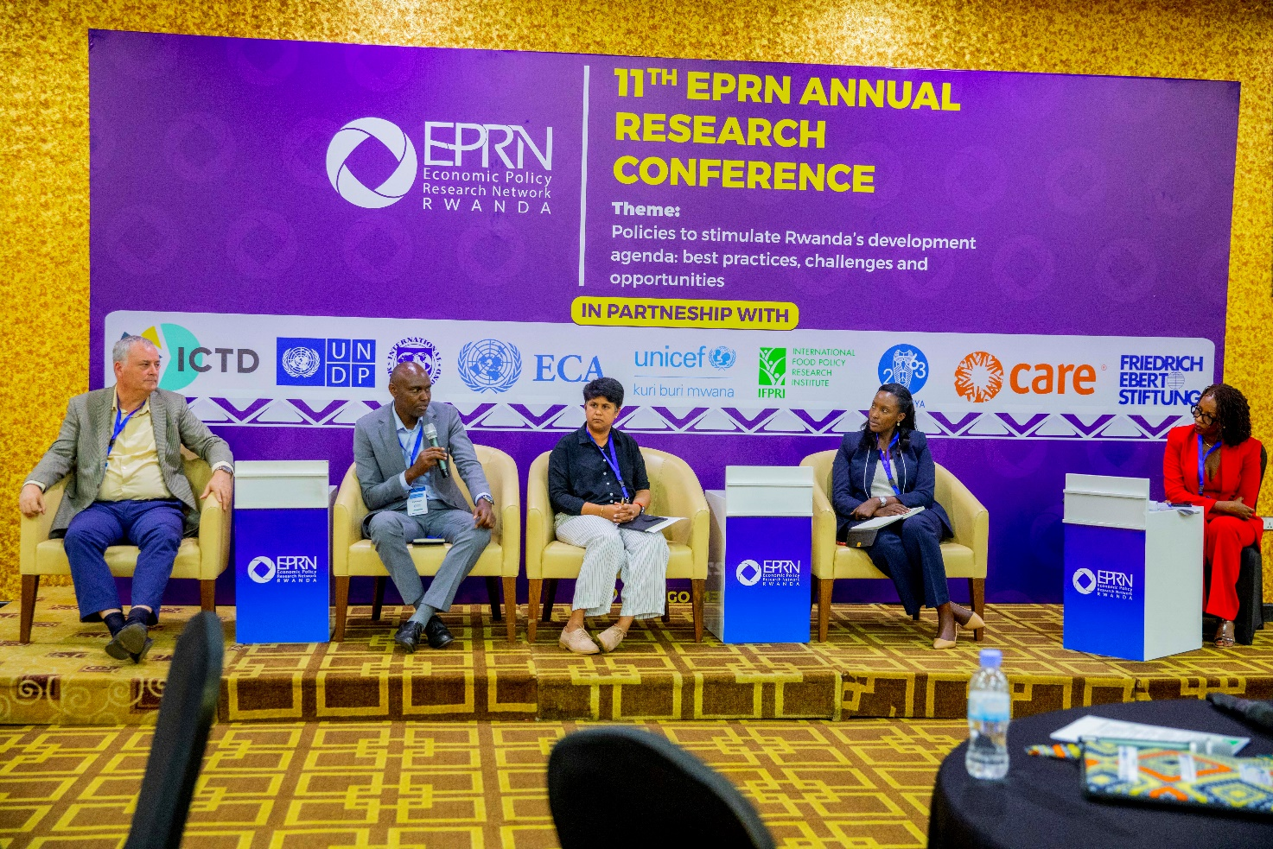
Photo 8: The 1st panel discussion

Key Highlights from the panel discussions
The session moderated by Anne-Lyse Bizindavyi opened with reflections on the increasing frequency and intensity of socio-economic shocks, ranging from pandemics and climate events to geopolitical tensions and commodity price volatility and the urgency for countries, especially in Africa, to strengthen economic resilience.

Key Discussion Points;
Stella Nteziryayo from MINECOFIN emphasized Rwanda's proactive approach in integrating resilience into national planning frameworks. She noted that the government had strengthened early warning systems and prioritized social protection as a buffer against household-level shocks. She highlighted that the National Strategy for Transformation (NST1) had mainstreamed resilience-building actions across sectors, including agriculture, health, and disaster risk management.

Johnson Rukundo of UNDP discussed the critical role of governance and institutional capacity in fostering resilience. He explained that strong institutions allowed for quicker and more coordinated responses to crises. He pointed to Rwanda’s COVID-19 recovery as a testament to institutional readiness and highlighted the importance of inclusive planning to protect vulnerable populations.

Honita Cowaloosur from UNECA underscored the need for economic diversification. She argued that over-reliance on a few sectors (e.g., tourism or exports of primary commodities) exposed economies to external shocks. Honita advocated for investment in digital transformation, regional trade integration under the AfCFTA, and building domestic industrial capacity as key pathways to resilience.

James Warner from IFPRI brought in a food systems lens, highlighting how food insecurity and rising input costs had amplified household vulnerability. He stressed the importance of supporting smallholder farmers through climate-smart agriculture, storage infrastructure, and market access. He also shared data showing that shocks to food prices had immediate and disproportionate effects on the poorest households, calling for targeted subsidies and price stabilization mechanisms.

Implications
The panelists agreed that resilience must be systemic, involving fiscal policy, social protection, infrastructure, and innovation. Fragmented or short-term interventions were deemed inadequate. The discussion highlighted a growing consensus on the importance of data and evidence in guiding resilience policies, especially in identifying who is most affected and where resources should be directed. There was also acknowledgment that building resilience requires inclusive approaches, ensuring the participation of youth, women, persons with disabilities, and marginalized groups in the design and implementation of resilience strategies.

Conclusions
- Strengthening institutional and policy coordination, particularly at local levels, emerged as a key priority.
- Investments in adaptive social protection systems were seen as essential to shielding vulnerable households during future shocks.
- The session concluded that resilience is not only about bouncing back from crises but also about transforming economic systems to be more inclusive, shock-responsive, and sustainable.
- The panel called on development partners, governments, and civil society to collaborate in mainstreaming resilience-building in national budgets, development plans, and regional cooperation frameworks.

Session 2: Domestic Revenue Mobilization through effective tax policy administration

The 3rd presentation was delivered by Mr. Fabrizio Santoro, ICTD and was about Digitalization and State Capacity: evidence from Tax Digital Reforms in Africa
Dr. Fabrizio Santoro’s presentation, “Digitalisation and State Capacity: Evidence from Tax,” examines the transformative effects of digital reforms on tax administration in Sub-Saharan Africa, with a particular focus on the integration of digital public infrastructure (DPI). The presentation highlights that tax administrations across the region are increasingly adopting digital technologies, such as ITAX systems, electronic fiscal devices (EFDs), and e-filing, to improve revenue collection, as evidenced by research from the IMF and ICTD. These first-wave technologies have already proven impactful in raising revenue and improving efficiency.

Key Points:
A central theme of the presentation was the role of DPI, which encompasses foundational digital systems like digital IDs, digital payments, and data exchange platforms. DPI is defined as essential, society-wide digital capabilities that should be inclusive, interoperable, and publicly accountable. The ICTD’s DPI and Tax programme explores how these infrastructures can be leveraged to further enhance tax administration in lower-income countries.

One key point was the integration of digital ID systems with taxpayer registration. Evidence from Uganda and Ghana shows that such integration has significantly expanded the taxpayer base, especially among previously unreached groups such as rural populations, women, youth, and informal businesses. However, the impact on actual revenue collection is mixed, with compliance and administrative capacity gaps remaining, and concerns about data quality persist. The presentation also discussed the adoption of digital merchant payments as a pathway to improved tax compliance. Uptake of digital payments is influenced by factors like supply chain
Photo 9: Dr. Fabrizio Santoro, ICTD

usage, IT readiness, financial inclusion, and fiscal incentives. While the removal of fees and targeted incentives have boosted adoption in some contexts, cash remains dominant, and the positive effects on compliance tend to be limited and short-lived, sometimes offset by strategic taxpayer behavior.

Dr. Santoro emphasized that unlocking the full potential of DPI for tax administration requires several preconditions. These include shifting the culture of tax administrations to view themselves as data warehouses, investing in high-quality taxpayer data as a public good, expanding data sharing arrangements with third parties, and clarifying the permitted use of tax data. The development of APIs for secure data exchange, fostering partnerships with ecosystem actors such as app developers, and establishing data partnerships with academic and international organizations are also recommended. Additionally, creating incentives for adoption and ensuring the tax system is inclusive and equitable are highlighted as critical steps.

The implications of these findings are significant. While digitalization offers substantial opportunities for expanding the tax base and improving administrative efficiency, its success depends on addressing data quality, fostering inter-institutional collaboration, and ensuring inclusivity. The presentation concludes that for digital reforms to fully realize their promise, tax administrations must not only adopt new technologies but also embrace broader conceptual and cultural shifts, invest in partnerships, and prioritize the foundational elements of DPI. This approach will help build stronger state capacity and support the development of more effective, equitable tax systems in the digital era.

The 4th presentation was delivered by Mr. Abel Ntegano, MINECOFIN and was about Update on tax policy and tax laws in Rwanda
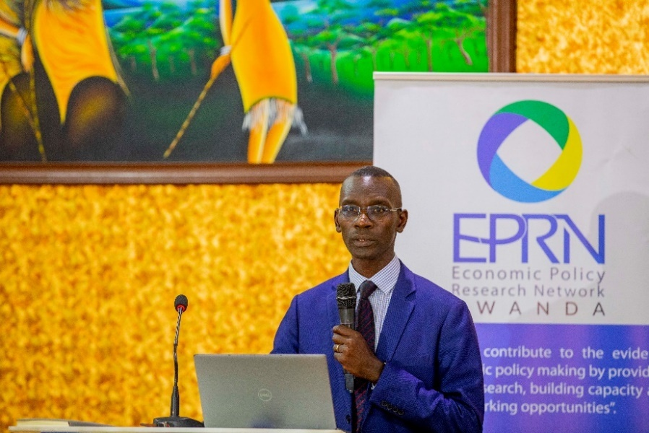
Key Points:
The primary objectives of the reforms were to broaden the tax base, increase fairness and competitiveness for domestic businesses, enhance revenue mobilization, streamline tax administration, and strengthen Rwanda’s economic resilience and self-reliance. A notable concern raised was the growing value of revenue foregone due to tax expenditures, which increased from RWF 557.9 billion in FY 2022/23 to RWF 599.7 billion in FY 2023/24, mainly driven by import duty exemptions to industries.
Photo 10: Mr. Abel Ntegano, MINECOFIN

VAT reforms included significant changes such as repealing VAT exemptions on mobile phones, ICT equipment, and business inputs, with some measures set to take effect from July 2026. The government also introduced VAT on fee-based financial services (effective July 2025) and reinstated VAT on fossil fuels and goods transport services by road. A sunset clause was set for VAT exemptions on zero-emission vehicles until June 2028, signaling a gradual shift toward broader tax coverage.

Excise duty reforms targeted harmful or high-consumption goods and services. Excise on beer was increased from 60% to 65%, and cigarette-specific rates rose from RWF 130 to RWF 230 per pack. Additionally, excise duties were introduced or increased on financial transactions (15%), airtime (15%), and telecommunication usage rates (gradually from 10% to 15% over three years). These adjustments aimed to align Rwanda’s tax regime with regional standards while boosting fiscal buffers.

On motor vehicle taxation, the reforms reinstated taxes on hybrid vehicles (including VAT and withholding tax), introduced excise based on vehicle age, and adjusted vehicle registration fees (unchanged since 2009) significantly upward. A road user charge was reinstated with tiered annual fees depending on vehicle type. Levies for fuel and road maintenance were revised fuel levy shifted to a percentage-based system (15% of CIF), and the strategic reserve levy was raised from RWF 32.73 to RWF 50 per liter, indicating a strategic move toward sustainable road financing.

Other notable measures included a sharp increase in taxes on gambling, with withholding tax on winnings rising to 25% and gross gaming revenue tax escalating to 40%. An environmental levy of 0.2% of CIF was introduced on plastic-packaged imports, and a 3% tourism tax on room costs was announced. A digital services tax on foreign online platforms providing services in Rwanda was also scheduled to begin in July 2025. Furthermore, the capital gains tax was revised from 5% to 10%, and the investment code was slated for revision to clarify criteria for tax holidays and gradually phase out certain incentives, except for renewable energy equipment, which would retain exemptions until 2030.

Implications of the reforms
The gradual withdrawal of exemptions and imposition of new consumption-based taxes aim to reduce revenue leakage and widen the tax net. However, the reforms may lead to short-term inflationary pressures, especially in energy and transport sectors, and could affect consumer behavior and business costs. Nonetheless, they also create incentives for efficiency, sustainability (especially in transport and energy), and long-term revenue stability.

Conclusion
The tax reform agenda reflects Rwanda’s strategic shift from dependency on aid and exemptions toward a self-financing, inclusive, and equitable tax system. The phased implementation approach offers room for businesses and households to adjust while signaling policy consistency and commitment to fiscal sustainability. The success of these reforms will depend on continued stakeholder engagement, robust enforcement, and effective communication to mitigate resistance and unintended socio-economic impacts.

The 5th presentation was delivered by Dr. Jean Paul MPAKANIYE, EPRN and INES and was about Evaluating the Impact of Effective Fiscal and Tax Policies on Stimulating Investments and Sustaining Long-Term Economic Growth


The presentation titled “Evaluating the Impact of Effective Fiscal and Tax Policy on Investment and Long-Term Economic Development in Rwanda (2014–2024)” by Dr. Jean Paul Mpakaniye provided an in-depth examination of Rwanda’s fiscal and tax reforms over a ten-year period and their implications for investment and macroeconomic development.
Key Points
The study aimed to evaluate how policy tools shaped public and private investment flows, identify mismatches between intentions and outcomes, and propose evidence-based strategies for sustainable growth. Over the last decade, Rwanda implemented substantial fiscal and tax reforms. These included the rollout of Electronic Billing Machines (EBMs), automation of VAT filing, the reduction of the corporate tax rate from 30% to 28%, and significant public investment in infrastructure.
Photo 11: Photo: Dr. Jean Paul MPAKANIYE, EPRN and INES

These reforms contributed to Rwanda maintaining an average GDP growth rate of over 7%, positioning it among Africa’s fastest-growing economies. However, challenges persisted, notably the underperformance of Foreign Direct Investment (FDI), the persistence of informality, and fiscal vulnerability to external shocks like the COVID-19 pandemic and global commodity price fluctuations.

The study adopted a causal research design, relying on secondary data from RRA, MINECOFIN, NISR, RDB, and international financial institutions. It applied multiple regression and time-series econometric models to explore the relationships between fiscal/tax policy variables and outcomes such as investment growth and GDP performance. The empirical results showed a statistically significant positive impact of public investment on GDP growth (β = 0.37), while high corporate tax rates had a negative effect (β = -0.21). Tax revenue was found to Granger-cause investment flows, which in turn Granger-caused GDP growth, confirming a long-run policy-outcome relationship.

Between 2014 and 2024, Rwanda’s tax-to-GDP ratio improved modestly from 15.1% to 17.2%, yet remained below the East African Community (EAC) benchmark of 20%. Automation greatly enhanced compliance, with 94% of VAT returns filed electronically by 2021, compared to less than 40% in 2014. Despite these achievements, gaps remained. The informal sector, comprising over 60% of employment, contributed less than 6% to tax revenue. Additionally, private investment lagged behind public infrastructure efforts, averaging just 13% of GDP compared to the targeted 18–20%, suggesting limited crowd-in effects.

The study highlighted that external shocks, particularly the COVID-19 pandemic and global inflation undermined policy performance. In 2020, Rwanda experienced a recession with GDP contracting by -3.4%, and inflation surged to 13.9% in 2022 due to food and fuel price volatility. The Rwandan franc depreciated by an average of 6% annually between 2020 and 2023, raising import costs and debt servicing burdens. These structural vulnerabilities revealed the importance of fiscal buffers and adaptive policy instruments.

A central finding was the moderating effect of governance quality. Regression models demonstrated that better governance significantly amplified the positive impact of tax policy on investment. Variables such as control of corruption, institutional effectiveness, and transparency emerged as critical to maximizing policy returns. This finding reinforced the need for performance-based budgeting, citizen engagement, and improved public finance monitoring systems.

In conclusion, the study affirmed that Rwanda’s fiscal and tax policies have been broadly development-enabling but are constrained by implementation challenges, informality, and external volatility. The success of these policies in attracting investment and driving long-term growth ultimately hinges on strengthening governance, enhancing coordination between public and private actors, and institutionalizing evaluation mechanisms.

The study put forward a set of policy recommendations: institutionalize mandatory cost-benefit analyses for tax incentives, align public investment with private sector needs through PPPs, maintain a competitive and stable tax regime, formalize the informal sector through digital inclusion and simplified compliance, build fiscal resilience via stabilization funds, and enhance equity through progressive tax policies. These strategies aim to make Rwanda’s fiscal and tax system more inclusive, adaptive, and aligned with Vision 2050 priorities.

The 2nd panel discussion session was about Domestic Revenue Mobilization through effective tax policy administration, moderated by Mr. John Karangwa, RRA, Abel Ntegano (MINECOFIN), Denis Mukama (RRA), Fabrizio Santoro (ICTD) and Pula Gabor (IMF)
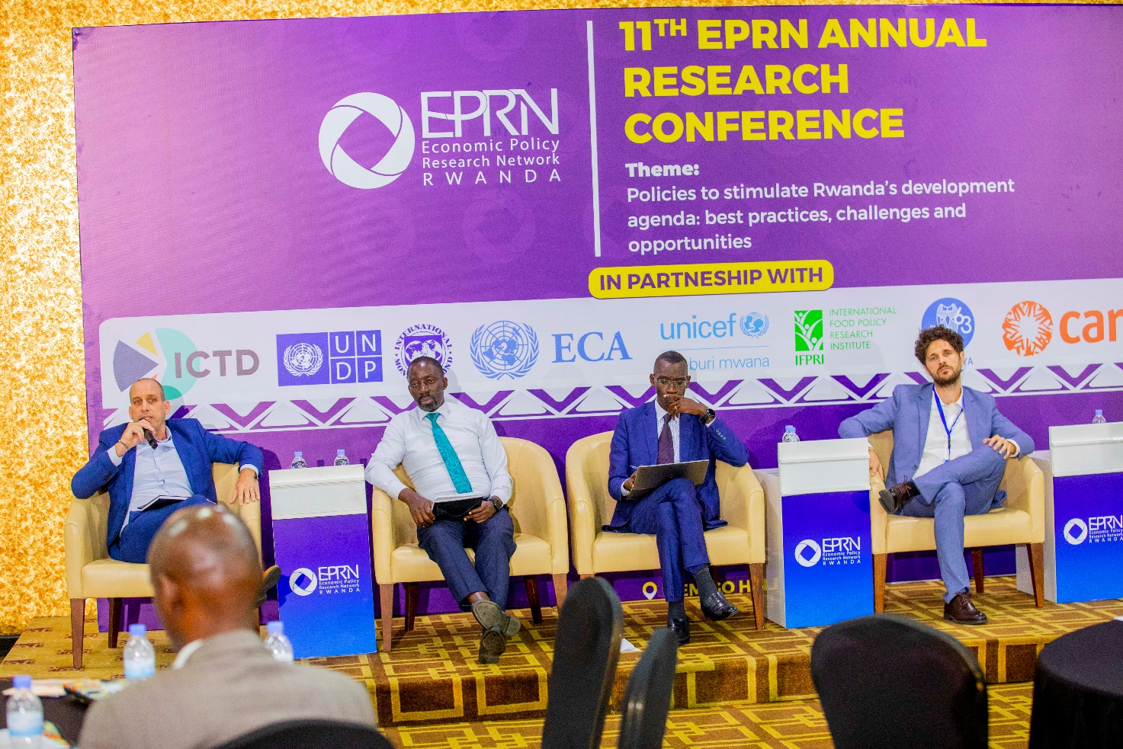
Photo 12: The 2nd panel discussion

Key Highlights from the panel discussions
For the session on Domestic Revenue Mobilization through Effective Tax Policy Administration moderated by Mr. John Karangwa (RRA) with panelists Abel Ntegano (MINECOFIN), Denis Mukama (RRA), Fabrizio Santoro (ICTD), and Pula Gabor (IMF), the following key discussion points, implications, and conclusions are recommended;

- Balancing Tax Policy Complexity and Administrative Capacity; The need to design tax policies that are simple and broad-based to avoid administrative burdens and compliance costs, especially in economies with limited administrative capacity. Complex tax incentives and special treatments often lead to revenue erosion and enforcement challenges.
- Strengthening Tax Administration to Enhance Compliance and Revenue Collection; Improving tax administration through capacity building, automation (e.g., digitized taxpayer registers, online filing), and targeted audits, especially for large taxpayers and sectors with high revenue potential.
- Tax Policy Reforms to Broaden the Tax Base and Reduce Revenue Erosion; Revisiting tax exemptions, incentives, and preferential treatments that erode the tax base and undermine fiscal sustainability. Emphasis on broadening the tax base through better mobilization of personal income taxes, VAT, and international trade taxes.
- Enhancing Public-Private Dialogue to Improve Tax Culture and Compliance; The role of continuous engagement between government, taxpayers, and private sector stakeholders to build trust, improve transparency, and encourage voluntary compliance.
- Addressing Sector-Specific Challenges, Especially in Extractive Industries; Tackling tax avoidance and improving compliance in high-revenue sectors such as mining and extractives through targeted audits and enforcement.
- Leveraging Digital Technologies and Data Analytics; Adoption of digital tools for tax filing, payments, and data analysis to improve efficiency, reduce compliance costs, and detect non-compliance.
- Managing Tax Policy and Administration in Crisis Contexts; Lessons from COVID-19 on maintaining tax compliance and revenue collection during economic shocks, including managing arrears and supporting businesses.

Implications
- Overly complex tax regimes can overwhelm tax administrations, reduce voluntary compliance, and increase costs of enforcement and taxpayer education. Simplified tax systems with relatively low rates and fewer exemptions are more efficient and easier to administer.
- Efficient tax administration increases voluntary compliance, reduces arrears, and ensures timely revenue collection. Automation and data analytics improve taxpayer registration, monitoring, and enforcement.
- Excessive tax incentives reduce government revenue and fiscal space, limiting funding for essential public services and infrastructure. Broadening the tax base supports macroeconomic stability and sustainable growth.
- Improved communication and collaboration can reduce tax evasion, clarify tax obligations, and foster a culture of compliance, which is essential for sustainable revenue mobilization.
- Extractive sectors often contribute significant revenue but also pose challenges due to complex transactions and transfer pricing issues. Focused reforms and administration can unlock substantial additional revenue.
- Digital transformation enables real-time monitoring, better taxpayer segmentation, and more effective audits, leading to higher revenue collection and improved taxpayer experience.
- Tax administrations must balance flexibility with enforcement, ensuring compliance while supporting economic recovery.

Conclusions
Tax policy should prioritize simplicity and broad tax bases to enhance compliance and reduce administrative costs, thereby improving domestic revenue mobilization. Investments in modernizing tax administration systems and staff capacity are critical to unlocking additional revenue and expanding fiscal space for public investment. Policymakers should prioritize reforms that widen the tax base while maintaining reasonable tax rates to enhance revenue without discouraging investment. Strengthening public-private dialogue is a vital complement to policy and administrative reforms, helping to build a supportive environment for tax compliance. Sector-specific tax administration reforms, informed by international best practices, can significantly boost domestic revenue mobilization. Embracing technology is essential for modern tax administrations to enhance revenue mobilization and taxpayer services. Crisis-responsive tax policy and administration frameworks are necessary to sustain revenue mobilization during shocks and build resilience.

These points provide a comprehensive framework for the session, highlighting the interplay between tax policy design, administration capacity, technology, stakeholder engagement, and sector-specific challenges to effectively mobilize domestic revenue for sustainable development.

DAY 2: 27th June 2025

Session 3: Youth in agribusiness, challenges and opportunities

The 6th presentation was delivered by four young entrepreneurs presenting their experiences and testimonies in agribusiness.
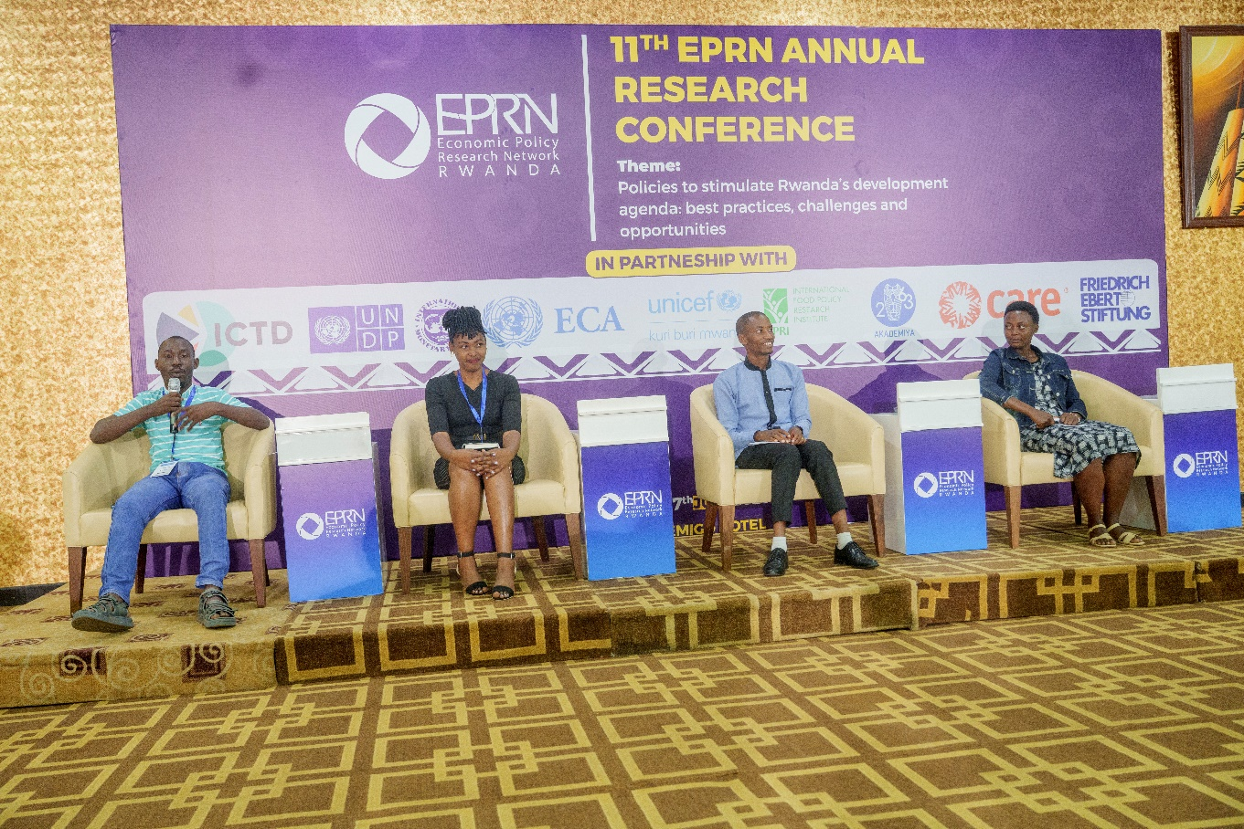
Photo 13: Four young entrepreneurs presenting their experiences and testimonies in agribusiness.

Key Points
Youth Engagement in Agribusiness through Government and NGO Support was highlighted. Young entrepreneurs benefited significantly from programs like SERVE CARE, DUHAMIC-ADRI, PROFEMME TWESEHAMWE, and SMART Nkunganire. These initiatives provide land access, technical support, farmer promoters, agricultural insurance, and capacity building. Diverse Agribusiness Ventures and Value Chain Participation were noted where youth are engaged in various agribusiness sectors: YAMURAGIYE Gloriose-Chili farming on 0.5 Has (personal) under SERVE CARE project with government of Rwanda support with 2 Has of land, harvested over 500,000 RwF worth, employs 3 other youth and several casuals regularly, key challenges being cost of pesticides; HABUMUGISHA Jean de la Croix -French Beans, works on half hectare but since increased to 1 Ha, supported under SERVE CARE project and DUHAMIC-ADRI providing farmer promoters, Government supports with Agric insurance 40% from farmer and 60% government and also SMART Nkunganire program, key challenges are land size limited and skills gaps; MUNEZERO Clarisse-Tomato farmer under SERVE CARE and PROFEMME TWESEHAMWE, who transformed from school teacher to farmer in Rwamagana, noted that youth can participate in other nodes of the value chain where there is no land available for them, key challenge is lack of subsidy for tomatoes and last but not least SINDAYIGAYA Gerard-Poultry farmer in Kirehe, having started with 5 birds and now at 700 birds on 0.4Has of land, supported by SERVE CARE and DUHAMIC ADRI (mobilization), he employs 1 permanent worker and 5 other youth on casual basis, key challenge is quality feeds and cost, drugs also with poor hatchery. Beyond farming, youth can participate in other value chain nodes (processing, marketing) especially when land access is limited.

Challenges Faced by Young Agripreneurs include;
- High input costs: pesticides (chili farming), quality feeds and drugs (poultry).
- Limited land size restricting scale and productivity.
- Skills gaps in modern farming techniques and business management.
- Lack of subsidies for certain crops (e.g., tomatoes).
- Quality issues in hatcheries affecting poultry production.

Employment Creation and Economic Impact
Youth-led agribusinesses create direct employment for other young people and casual workers. Successful enterprises demonstrate potential for income generation and rural economic development.

Implications
- Policy and Program Support: Continued and expanded government and NGO support is crucial for youth agripreneurs to overcome barriers such as land access, input costs, and skills development.
- Value Chain Development: Encouraging youth participation beyond farming into processing, marketing, and agritech, can enhance inclusivity and economic resilience.
- Capacity Building: Addressing skills gaps through targeted training and mentorship is essential to improve productivity and business sustainability.
- Input Subsidies and Quality Control: Introducing subsidies for key inputs and improving quality standards (e.g., hatcheries, feed) can reduce operational challenges.
- Employment and Poverty Reduction: Youth agribusinesses have strong potential to contribute to employment creation and poverty alleviation in rural areas.

Conclusions
Empowering youth in agribusiness is vital for accelerating CAADP implementation and building a resilient agricultural future. Multi-stakeholder collaboration involving government, NGOs, and private sector is key to providing comprehensive support. Addressing input costs, land constraints, and skills development will unlock greater youth participation and success in agribusiness. Showcasing young entrepreneurs’ success stories inspires replication and scaling of best practices. Supporting youth-led agribusiness contributes not only to economic growth but also to social stability and food security.

This summary captures the essence of the testimonies and discussion, highlighting practical insights and strategic directions for empowering youth in agriculture under CAADP frameworks.
The 3rd panel discussion session was about Youth in agribusiness, challenges and opportunities, moderated by Mr. Godfrey Gakwandi (CARE), Hela Gharbi (CARE), Jean Paul Ndagijimana (AGRA), Getaw Tadesse (AKADEMIYA2063) and Egide Mutabazi (MINAGRI)
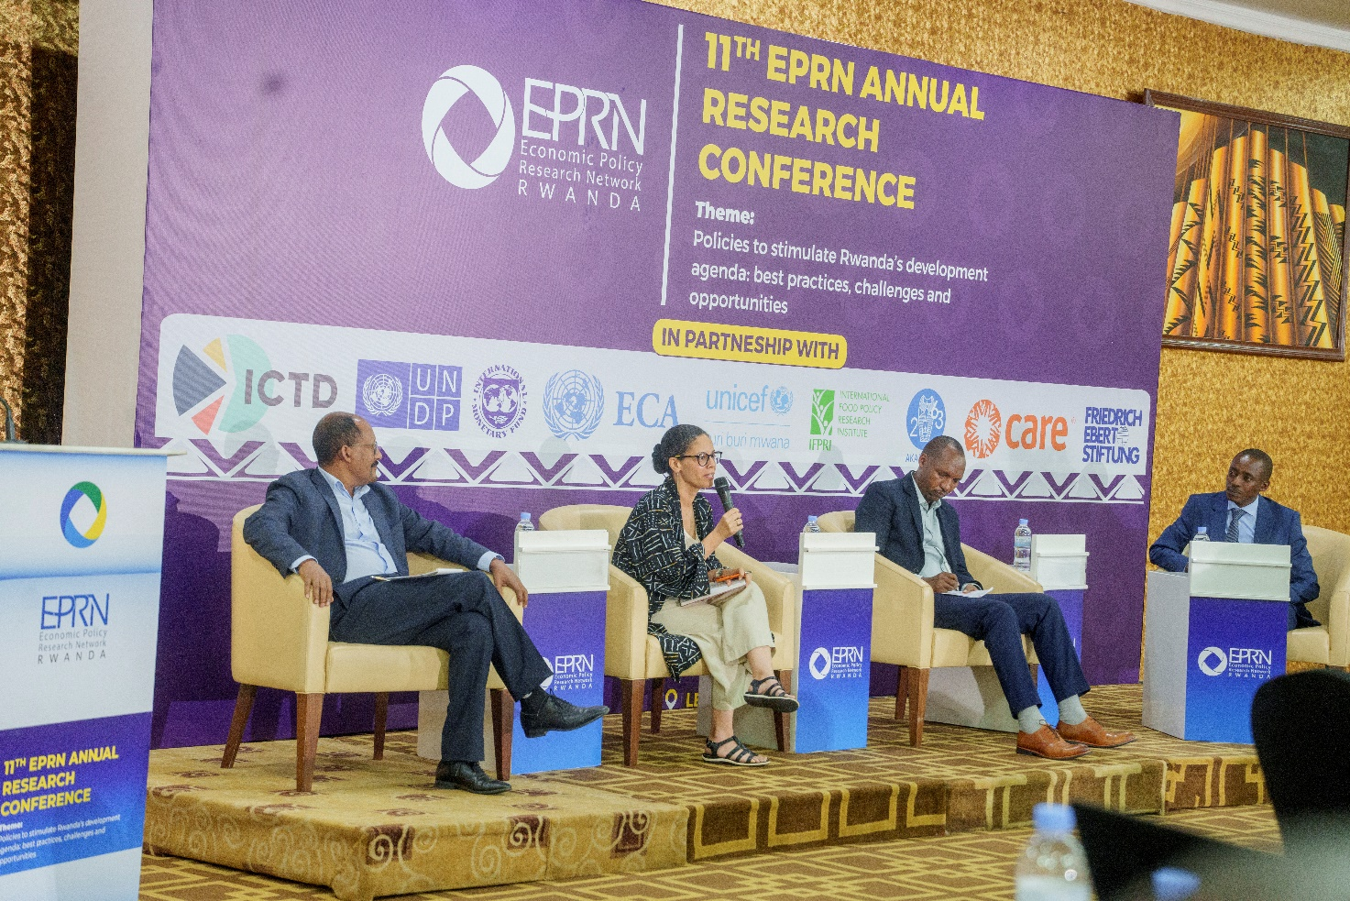
Photo 14: 3rd panel discussion

Key Highlights from the panel discussions:
The panel discussion on Youth in Agribusiness provided a multifaceted exploration of the current landscape, challenges, and opportunities for young people engaging in agriculture in Rwanda. The session was moderated by Mr. Godfrey Gakwandi (CARE) and featured expert insights from representatives of CARE, AGRA, AKADEMIYA2063, and MINAGRI, highlighting ongoing initiatives, policy frameworks, and innovative approaches to empower youth in the sector.

Key Discussion Points
- Government Initiatives and Policy Frameworks (MINAGRI); MINAGRI emphasized its commitment to addressing youth unemployment through flagship projects under the current financial year, focusing on job creation in horticulture, greenhouses, piggery, and poultry farming. The implementation of the Strategic Plan for the Transformation of Agriculture (PSTA V) prioritizes youth and women’s employment, supported by projects such as CDAT, CSAIP phases 1 and 2, and irrigation infrastructure. MINAGRI highlighted efforts to improve youth access to agricultural equipment and inputs, facilitated through matching grants under the Single Project Implementation Unit (SPIU). Incentives such as lower interest rates and less stringent loan conditions are designed to reduce financial barriers for young agripreneurs.

- Grassroots Empowerment and Gender Inclusion (CARE); CARE shared its 40-year experience in Rwanda, leveraging Village Savings and Loan Associations (VSLAs) and Farmer Field Schools to support over 15,000 village startups and 40,000 groups, with 80% women participation. The organization emphasized business mentoring through VSLAs and the use of community scorecards to address gender norms and structural barriers. CARE’s completed project on land access successfully negotiated 40,000 hectares for group use, enhancing youth and women’s ability to engage in agribusiness. Collaboration with the Association of Micro Finance Institutions in Rwanda strengthens financial inclusion for marginalized groups.
- Data-Driven Policy and Skills Development (AKADEMIYA2063); AKADEMIYA2063 highlighted the role of data and evidence in shaping youth-focused agricultural policies, noting current gaps in measuring youth-specific outcomes within CAADP frameworks. The institution stressed the importance of integrating agriculture into education curricula and facilitating internships, such as those through the Rwanda-Israel Center of Agricultural Excellence (RICA), to bridge skills gaps. Innovations supporting youth include organic farming techniques and partnerships with financial institutions like DUHAMIC, AMIR, and ProfemmeTwese. Climate change remains a major challenge, prompting collaborations with fintech companies to develop climate-smart business models and digital tools such as AI-driven crop mapping and satellite-based soil testing. AKADEMIYA2063 also partners with Mastercard and MINAGRI to enhance monitoring and evaluation systems for agricultural forecasting and planning.

- Market Access, Financial Inclusion, and Ecosystem Strengthening (AGRA)
AGRA presented its five-year strategic plan targeting the creation of 132,000 dignified jobs for youth, with a focus on value chains such as avocado, poultry, chilies, maize, beans, and Irish potatoes. The strategy emphasizes youth-centered, gender-responsive approaches to build capacity, improve productivity, and enhance access to finance and markets. AGRA works to strengthen coordination among partners and promote youth entrepreneurship ecosystems, addressing barriers such as limited technical skills, high transaction costs, and market access challenges. The organization supports sustainable agriculture by connecting young farmers directly with markets and fostering inclusive business environments.

Implications
- Holistic Support Systems; The panel underscored the importance of integrated support combining policy incentives, capacity building, financial access, and market linkages to enable youth agripreneurs to thrive.
- Gender and Social Inclusion; Targeted interventions addressing gender norms and structural inequalities are critical to ensuring equitable participation of young women and marginalized groups.
- Skills and Innovation; Addressing skills gaps through education reforms, internships, and technology adoption is essential to modernizing agriculture and enhancing youth employability.
- Climate Resilience; Climate change adaptation strategies and digital innovations must be mainstreamed into youth agribusiness models to safeguard productivity and sustainability.
- Data-Driven Decision Making; Improved data collection and analysis on youth outcomes will enable more effective policy design and resource allocation.

Conclusions
The discussion concluded that empowering youth in agribusiness is pivotal for Rwanda’s agricultural transformation and economic development. A multi-stakeholder approach involving government agencies, development partners, financial institutions, and grassroots organizations is necessary to create an enabling environment for youth-led agribusinesses. By addressing financial, technical, and social barriers, and leveraging innovations and data, Rwanda can accelerate youth employment, enhance food security, and build a resilient agricultural sector aligned with CAADP and national development goals. This write-up synthesizes the panel’s insights, reflecting ongoing efforts and strategic priorities to harness youth potential in agribusiness while acknowledging the challenges that require coordinated action.

Session 4: Gender policies: What is already there? What is missing? How can we enforce them?
The 4th panel discussion session was about Gender policies: What is already there? What is missing? How can we enforce them? moderated by Sonia Honorine, Alumni, FWG,
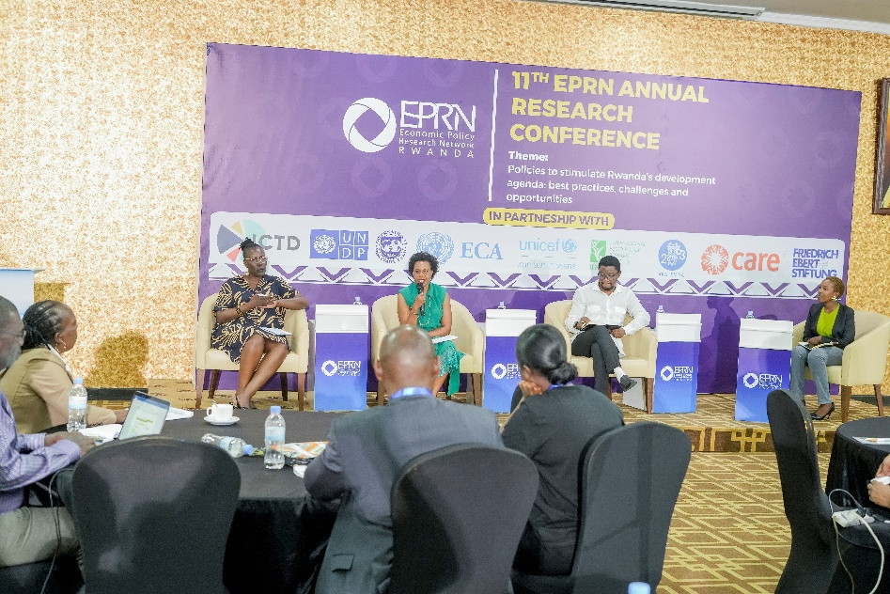
Photo 15: 4th panel discussion

Key Highlights from the panel discussions
The panel discussion on Gender Policies provided a critical examination of Rwanda’s gender equality landscape, focusing on what policies currently exist, the persistent gaps, and practical ways to strengthen enforcement. The session was moderated by Sonia Honorine and featured expert insights from representatives of MIGEPROF, FES, and civil society, with an emphasis on the interplay of social norms, gender equality and women’s empowerment (GEWE), and power dynamics.

Key Discussion Points
- Existing Gender Policy Frameworks; Rwanda’s Revised National Gender Policy (2021) aims to mainstream gender across all sectors, addressing inequalities in access to resources, education, health, leadership, and social protection. The policy identifies eight priority areas including engendering national planning, accelerating women’s economic empowerment, promoting gender equality in social sectors, leveraging positive cultural norms, and engaging men and boys in gender promotion.

Recent national efforts include the introduction of RS 560:2023, Rwanda’s first national gender equality standard, designed to institutionalize accountability and promote inclusive governance within organizations. The government’s commitment is further reflected in frameworks like the National Strategy for Transformation (NST1) and Vision 2050, which embed gender equality as a crosscutting priority for sustainable development.

- Challenges and Missing Elements; Despite strong policies, negative social norms and gender stereotypes persist, undermining progress on gender equality and women’s empowerment. Power dynamics within households and communities often limit the effective complementarity between men and women, affecting decision-making and resource control. There remain gaps in gender mainstreaming accountability and limited gender-related expertise across sectors, hindering effective policy implementation. Enforcement mechanisms are often weak, with insufficient monitoring and community-level ownership of gender equality goals. The engagement of men and boys, while recognized as critical, requires more robust and sustained programming to transform harmful norms around manhood and womanhood.

- Enforcement Strategies and Opportunities; Strengthening accountability frameworks through tools like the Gender Equality Seal and RS 560:2023 can institutionalize gender-responsive practices in both public and private sectors. Enhancing community engagement by localizing gender equality goals and using tools such as community scorecards fosters grassroots ownership and addresses cultural barriers. Expanding gender equality education and advocacy targeting youth and men, including positive masculinity workshops and gender clubs in schools and universities, can shift social norms over time. Building capacity by increasing gender expertise within institutions and supporting continuous training ensures better policy mainstreaming and responsiveness. Promoting inclusive workspaces with safer environments, gender-sensitive procurement, and support facilities (e.g., nursing rooms) encourages women’s participation and retention in workplaces. Collaboration between government, civil society, and development partners remains vital to mobilize resources, share best practices, and monitor progress toward gender equality targets.

Implications
- The persistence of negative social norms and unequal power relations necessitates a holistic approach that combines policy frameworks with cultural and behavioral change interventions.
- Institutionalizing gender equality through national standards and certification can enhance enforcement but requires strong political will and resource allocation.
- Community-level engagement and education are critical to translating policy commitments into tangible outcomes, particularly in rural and vulnerable populations.
- Engaging men and boys as allies is essential to dismantle harmful stereotypes and promote equitable gender relations.
- Continuous monitoring and data collection on gender outcomes will improve accountability and inform adaptive policy responses.

Conclusions
The panel concluded that Rwanda has a robust foundation of gender policies and frameworks that reflect a national commitment to gender equality and women’s empowerment. However, gaps remain in enforcement, particularly around social norms, power dynamics, and institutional capacity. Effective enforcement requires a multi-pronged strategy involving:

- Strengthening institutional accountability through standards like RS 560:2023,
- Deepening community engagement and ownership,
- Expanding education and advocacy targeting youth and men,
- Building gender expertise within institutions,
- Ensuring safe and inclusive work environments.

By addressing these dimensions, Rwanda can accelerate progress toward achieving gender equality, transforming both policy intent and social realities for women, men, girls, and boys. The panel’s insights are provided here and reflects the current state of gender policies in Rwanda, highlighting strengths, challenges, and actionable pathways for enforcement and transformation.

The 7th presentation was delivered by Birasa Nyamulinda, EPRN and was on Overview of African Adaptation Atlas
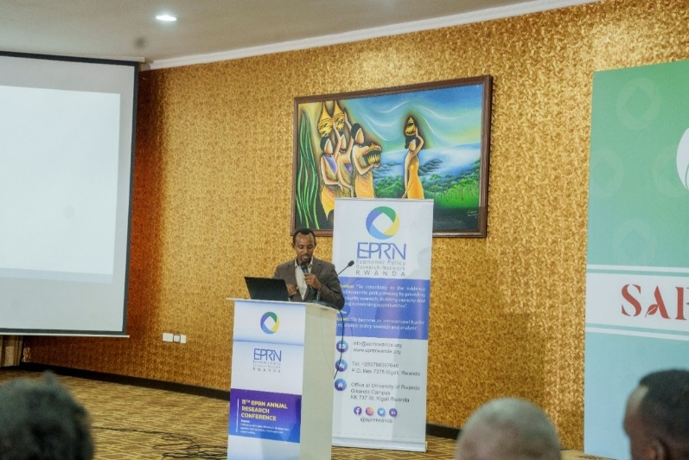
Photo 16: Prof Birasa Nyamulinda, EPRN

Key Points
Prof. Birasa Nyamulinda provided an insightful presentation on the African Agriculture Adaptation Atlas, a cutting-edge digital platform developed with support from the Bill & Melinda Gates Foundation and key African partners. The Atlas serves as a comprehensive, data-rich resource designed to guide climate adaptation planning and investment decisions across the continent, particularly targeting smallholder agricultural producers vulnerable to climate change.

The Atlas integrates diverse datasets, tools, and guidelines to support stakeholders in understanding climate risks, vulnerabilities, and adaptation options at multiple scales. It bridges scientific knowledge with practical applications by offering both top-down aggregated analyses and bottom-up sector-specific assessments, enabling tailored decision-making for countries and regions.

Focusing on the Rwanda case study, Prof. Nyamulinda highlighted how the Atlas complements Rwanda’s national climate strategies, including the National Strategy for Climate Change and Low Carbon Development (GGCRS) and the country’s Nationally Determined Contributions (NDCs) under the Paris Agreement. Rwanda’s adaptation priorities, spanning agriculture, forestry, water, land use, and tourism, are well aligned with the Atlas’s sectoral focus, enhancing integrated planning and data management across ministries and agencies.

The case study demonstrated the Atlas’s utility in supporting Rwanda’s National Strategy for Transformation (NST1), particularly the pillar on sustainable natural resource management and green economy transition. It also illustrated how the Atlas aids in monitoring and evaluating adaptation outcomes, feeding into Rwanda’s emerging Climate Adaptation Monitoring, Evaluation, and Learning (MEL) System.

Prof. Nyamulinda emphasized ongoing efforts by the Economic Policy Research Network (EPRN) to integrate the Atlas into national policy tools through the African Network of Policy Research Institutes (ANAPRI). This integration aims to strengthen evidence-based policymaking by providing accessible, actionable climate data to government decision-makers, development partners, and local stakeholders.

The presentation underscored the importance of user engagement and feedback in refining the Atlas platform, ensuring it meets the diverse needs of African countries. Rwanda’s experience serves as a model for leveraging innovative digital tools to enhance climate resilience, improve resource allocation, and accelerate adaptation actions in vulnerable sectors.

In conclusion, the African Agriculture Adaptation Atlas represents a transformative resource for climate adaptation in Africa, with Rwanda’s case study exemplifying how data-driven approaches can support national strategies, foster cross-sector collaboration, and build a resilient agricultural future.

This write-up synthesizes the key elements of the presentation, reflecting the Atlas’s role as a decision-support tool and Rwanda’s leadership in applying it to national climate adaptation efforts.

Conference Recommendations
Based on presentations and brainstorming sessions, participants in the conference came up with the following key recommendations; and tasked EPRN to make a follow-up to know where each recommendation belongs to, and send them formally to the concerned institutions:

Recommendation 1: Boosting Inclusive Economic Growth Emphasis was placed on addressing inequality and informality in the economy, with a push for policies that ensure all groups—especially youth, women, and people with disabilities—can contribute to and benefit from national development.
Recommendation 2: Enhancing Productivity and Job Creation Despite strong GDP growth, Rwanda faces challenges in job creation and productivity. The conference recommended targeted investments in innovation, infrastructure, and skills development to close this gap.
Recommendation 3: Strengthening Human Capital Investing in education, health, and social protection systems was highlighted as essential for long-term transformation. This includes expanding access and improving quality to ensure no one is left behind.
Recommendation 4: Climate Resilience and Green Growth With Rwanda’s goal to become a low-carbon, climate-resilient economy by 2050, the conference underscored the need for sustainable resource management and climate-smart policies.
Recommendation 5: Leveraging Public Private Partnerships (PPPs) - increasing private sector investment through innovative financing mechanisms, such as green bonds and climate funds, can help bridge funding gaps and ensure sustainable financing.
Recommendation 6: To enhance internal resource mobilization, RRA should invest more in sensitization, education, and communication campaigns and engage broadly with civil society actors and associational bodies to promote a culture of tax compliance
Recommendation 7: Engender tax administration by adopting best practices (statistics and data collection)
Recommendation 8: Continuous awareness raising for women and men through men-engage programs to ensure everyone understands why we need gender equality and avoid misunderstanding between gender VS sex.
Recommendation 9: Encourage a “mindset change” among youth to perceive agriculture as a modern, tech-enabled business opportunity rather than subsistence farming. Support ICT-driven platforms (e-Growers info portals, mobile-based systems) to empower youth with digital tools
Recommendation 10: A big number of Agriculture under graduates in most cases are general practitioners while agriculture as a sector hss got many disciplines like crop production, seed multiplication, crop pests and diseases etc-- There is therefore need for more specialization in different fields.
Recommendation 11: For agriculture sanitary mandate. Agriculture private practioners to organize themselves into companies or cooperatives and make an arrangement or agreement with the government to provide extension services on its behalf.
Recommendation 12: Policy Innovation and Data-Driven Decision Making: The importance of evidence-based policymaking was a recurring theme, with calls to strengthen research institutions and integrate tools like the Atlas for policy analysis.

Closing remarks

The closing remarks were given by Dr Emmanuel Twagirimana from the Ministry of Finance and Economic Planning and he started by thanking all participants for having spent the two days discussing across a range of critical topics shaping Rwanda’s development agenda. Dr Emmanuel highlighted the following key points:

- Economic Resilience and Inclusive Growth; the conference emphasized the importance of building resilience in the face of global shocks, with a focus on inclusive economic growth that leaves no one behind. Rwanda’s progress in job creation, export growth, and poverty reduction was celebrated, while recognizing the ongoing need to address inequality, informality, and productivity gaps.
- Domestic Resource Mobilization; sessions on tax policy and administration underscored the need for simplified, efficient, and equitable tax systems. The role of digitalization and data-driven reforms in expanding the tax base and enhancing compliance was particularly noted as vital for sustainable financing of our development ambitions.
- Youth in Agribusiness; the panel on youth engagement in agriculture showcased inspiring testimonies and best practices, reaffirming the sector’s potential for job creation, innovation, and rural transformation. The importance of policy incentives, access to finance, skills development, and multi-stakeholder collaboration was clearly articulated.
- Gender Equality and Social Inclusion; discussions on gender policies highlighted Rwanda’s robust frameworks, while calling for stronger enforcement, community engagement, and the dismantling of persistent social norms that hinder women’s empowerment and equal participation.
- Climate Adaptation and Innovation; the presentation of the African Adaptation Atlas and the Rwanda case study demonstrated the power of data and digital tools in guiding climate adaptation, resource management, and policy planning, crucial for safeguarding our agricultural sector and supporting our green growth agenda.
- Contribution to Rwanda’s Development; the knowledge shared and recommendations generated at this conference will directly inform our policy and programmatic actions. Key contributions include:
- Strengthening evidence-based policymaking and fostering a culture of continuous learning and innovation.
- Supporting the implementation of the National Strategy for Transformation (NST2) and Vision 2050, particularly in agriculture, food security, and rural livelihoods.
- Advancing inclusive and climate-resilient growth by empowering youth, women, and marginalized groups as drivers of transformation.
- Enhancing collaboration between government, research institutions, development partners, and the private sector for greater impact.

He extended his gratitude to EPRN, all presenters, panelists, and participants for their dedication and insights and called upon all participants to continue harnessing research, innovation, and partnership to build a more resilient, inclusive, and prosperous Rwanda.

ANNEX 1: CONFERENCE AGENDA

Day 1: 26th June 2025
Time | Session | Facilitators / Presenters
08:30 - 09:00 | Arrival and registration | EPRN/Lemigo
09:00 - 09:05 | Introduction of the conference | Seth Kwizera, EPRN
09:05 - 09:20 | Welcome Remarks | - Kasai Ndahiriwe, EPRN  - Giulia Mascagni, ICTD
09:20 - 09:30 | Remarks by the Guest of Honour | Hon. Minister, Ministry of Finance and Economic Planning (TBC).
09:30 - 10:00 | Key Note Speaker: 1st Presentation  Rwanda’s Developmental Agenda and Challenges in a Regional Context – What’s Next? | Andrew Mold, UNECA
10:00-10:15 | Comments, Questions and Answers | All
10:15 - 10:40 | Group Photo and Health Break | All
10:40 - 11:10 | 2nd Presentation  Green Financing for sustainable development and resilience | Osten Chulu, UNDP
11:10 - 11:25 | Comments, Questions and Answers | All
11:25 - 12:30 | 1st Panel Discussion  Enhancing resilience of economies in this era of socio- economic shocks  Moderator: Anne-Lyse Bizindavyi, UNHCR and EPRN Board Member | Discussants:  - Stella Nteziryayo, MINECOFIN  - Johnson Rukundo, UNDP  - Honita Cowaloosur, UNECA  - James Warner, IFPRI
LUNCH BREAK
14:00-15:30 | 3rd and 4th Presentations  - Digitalization and State Capacity: evidence from Tax Digital Reforms in Africa  - Update on tax policy and tax laws in Rwanda  - Evaluating the Impact of Effective Fiscal and Tax Policies on Stimulating Investments and Sustaining Long-Term Economic Growth  Moderator: John Karangwa, RRA | - Fabrizio Santoro, ICTD  - Mr. Abel Ntegano,MINECOFIN  - Dr. Jean Paul MPAKANIYE, EPRN and INES
15:30-15:50 | Health Break

15:50-16:50 | 2nd Panel Discussion  Domestic Revenue Mobilization through effective tax policy administration  Moderator: Moderator: John Karangwa, RRA | Discussants:  - Abel Ntegano, MINECOFIN  - Denis Mukama, RRA  - Fabrizio Santoro, ICTD  - Pula Gabor, IMF
Day 2: 27th June 2025
Time | Session | Facilitators / Presenters
09:00-09:05 | Wrap-up of the first day sessions | Seth Kwizera, EPRN
09:05-10:00 | 5th Presentation  - Empowering Youth: Accelerating CAADP Implementation for a Resilient Future  - Best practices (testimonies) of young entrepreneurs in agribusiness | - 4 young entrepreneurs presenting their experiences and testimonies in agribusiness:  - YAMURAGIYE Gloriose-Chili  - HABUMUGISHA Jean de la Croix -Fresh Beans  - MUNEZERO Clarisse-Tomato  - SINDAYIGAYA Gerard-Poultry
10:00-11:00 | 3rd Panel Discussion  Youth in agribusiness, challenges and opportunities  Moderator: Godfrey Gakwandi, CARE | Panelists:  - Hela Gharbi, CARE  - Jean Paul Ndagijimana, AGRA  - Getaw Tadesse, AKADEMIYA2063  - Egide Mutabazi, MINAGRI
11:00-11:30 | Health Break | All
11:30-12:30 | 4th Panel Discussion  Gender policies: What is already there? What is missing? How can we enforce them?  - Moderator: Sonia Honorine, Alumni, FWG | Panelists:  - Silas Ngayaboshya, MIGEPROF  - Salvatrice Musabyeyezu, FES  - Ms. Annette Natukunda MUKIGA  - UNWOMEN (TBC)
12:30 Lunch
14:00-14:50 | - Overview of African Adaptation Atlas  - Presentation of the Rwanda Case Study | - International Centre for Tropical Agriculture (CIAT)  - Birasa Nyamulinda, EPRN
14:50-15:20 | Plenary discussion | All
15:20-15:25 | Summary of key take away/Conference  Recommendations | EPRN Secretariat
15:25-15:30 | Closing Remarks | DG –Rwanda Agriculture Board (TBC)
15h30 | Coffee break and networking | All

ANNEX 2: BIOGRAPHIES OF SPEAKERS

PANEL 1: Enhancing resilience of economies in this era of socio- economic shocks
Thursday 26th June 2025 Before noon
MODERATOR:
Anne-Lyse Bizindavyi is a seasoned Economist & Development Expert with more than ten years of experience in M&E within the fields of Programme/Project Design, Development and Management applied in the humanitarian, development and business fields. Since January 2020, Anne-Lyse has been serving as a Programme Monitoring Officer for UNHCR Rwanda, where she leads impact monitoring for the country operation program with an annual budget of approximately USD 50 million and coordinate over 50 partners who support over 135,000 refugees and host communities. With a background in development economics and extensive regional experience across East Africa in SMEs, Private Sector and Partnership development, Anne-Lyse Bizindavyi has contributed to various impactful initiatives. Anne-Lyse is a Board Member of EPRN and holds a Master’s degree in Economics from the University of Rwanda and a Master’s in Tourism and Entrepreneurship Development from Université du Québec à Montréal (Uqam), Canada. She is fluent in both French and English.
PANELISTS:
Ms. Stella Rusine Nteziryayo is Rwanda’s Chief Economist within the Ministry of Finance and Economic Planning. She is known for her leadership in debt sustainability, macroeconomic policy, fiscal planning, and climate finance. Her work includes designing Rwanda’s MediumTerm Economic Framework (MTEF), helping the country navigate crises like COVID-19. She led Rwanda’s first bond issuance in 2013 and subsequent Eurobond, and developed the Climate and Natural Resources Finance Strategy.
Honita Cowaloosur is an Economic Affairs Officer at UNECA, and works extensively on the blue economy. She recently led the formulation exercise of the EAC Blue Economy Strategy and Action Plan by UNECA. Honita has served the Government of Mauritius for over a decade in capacity as Head of Strategy, Economic Development Board, Head of Business Development Services, SME Mauritius and managed the exports towards Africa portfolio of the Trade Promotion Agency of Mauritius. She actively researches and publishes on SEZs models of development.
Johnson B. Rukundo is an Economist, at present working with UNDP Rwanda office and has previously worked as an Economic Advisor at UNDP-Juba South Sudan office since February 2023. He provides policy advice to the Resident Representative of UNDP and is responsible for research and development and engaged in formulation of strategies and plans for solutions to economic challenges. Prior to joining UNDP as a consultant, he worked as a Consultant- Economist at the World Bank country office in Rwanda for 2 years, where he delivered a report on the Public Expenditure Review (PER) and the provided technical support in the analysis of health insurance data to produce a capitation financing policy, that is currently being implemented. He also delivered on nutrition budget tagging for the National Child Development Agency (NCDA) by developing sector specific guidelines aligned to NCDA Strategic Plan. Johnson is one of EPRN senior members. He holds a PhD in Economics.
James Warner is a Research Fellow in the Development Strategies and Governance Unit and is the Program Leader for Rwanda’s Strategy and Support Program (RSSP). He first joined IFPRI in 2013 and was the office head of IFPRI’s Eastern and Southern Africa Office, based in Addis Ababa, Ethiopia. Before joining IFPRI, James worked extensively in eastern and southern Africa as both an academic and economic policy consultant and was a tenured Associate Professor at the College of Wooster in Wooster, Ohio, USA. Recent publications include papers on rural mobile phone ownership from a gender perspective, economics of acid soil remediation, biofortification, nutrition supplementation strategies, and smallholder agricultural commercialization. His U.S. education includes a PhD from the University of Utah, master’s degrees from the University of New Hampshire and University of California, and a bachelor’s degree from Bates College in Lewiston, Maine.
PANEL 2 : Revenue Mobilization through effective tax policy administration
Thursday 26th June 2025 - Afternoon
MODERATOR :
John Karangwa presently serves as the Head of Research and Policy Analysis at the Rwanda Revenue Authority, leveraging over a decade of public sector experience specializing in official statistics and public economics. Previously, he held the role of Principal Statistician overseeing Social and Vital Statistics at the National Institute of Statistics of Rwanda. John holds a BSc. in Applied Statistics from the National University of Rwanda, a Post Graduate diploma in Poverty Reduction : Policy and Practice from the University of London, and an MSc in Applied Economics from University College Dublin (UCD). His research pursuits include tax compliance, tax policy, tax administration, and the development of efficient and equitable tax systems. These efforts have significantly influenced the evolution of tax policy and have played a meaningful role in advancing the strategic initiatives of RRA.
PANELISTS :
Fabrizio Santoro is a Research Fellow at the Institute of Development Studies, and the Research co- Lead for the ICTD programme on Digital Public Infrastructure and Tax. His main research interests relate to governance, public finance, and taxation, with a strong focus on impact evaluation and data analysis. He holds a PhD in Economics from the University of Sussex.
Abel NTEGANO is one of senior members of EPRN and holds a Master’s degree of Development Policy with specialization in Fiscal Policy and Tax Policy from Korean Development Institute School of Public Policy and Management ; and he is currently a Director General of Tax policy in the Ministry of Finance and Economic Planning with 30 years’ experience in Economic Development field with a focus on Tax Policy, Fiscal Policy, Public Finance, Operations of Economic Development, Poverty Reduction and Government Finance Statistics. Abel is a Member of the EAC Fiscal Affairs Committee in charge of harmonization of fiscal and Tax policies of The East African community towards the EAC Monetary Union requirements, Member of National Implementation committee of the EAC common Market Protocol and Lecture in University of Rwanda and University of Adventist of Central Africa focussing on Budget Process and monitoring in Rwanda.
Mr. Mukama Denis works for the Rwanda Revenue Authority (RRA) as the Interim Commissioner for Strategy and Risk Analysis. He has worked for the tax administration for close to 18 years now, most recently as the Assistant Commissioner for Research, Planning and Statistics having risen through the ranks from joining the institution as a statistics officer. In his current post, Denis is responsible for overseeing institutional research activities, tax policy and statistical analysis, risk management, data science and ensuring they support management decision making. He is also responsible for ensuring the institutional direction is articulated through preparing, monitoring and evaluating the institutional plans. Denis works closely with the Ministry of Finance on tax policy and administration matters including developing and monitoring implementation of Rwanda’s Medium Term Revenue Strategy (MTRS), preparing Tax Expenditure reports and annual and medium-term tax revenue projections. Denis is a member of EPRN since its establishment in 2018.
Mr. Gabor Pula, a national of Hungary, who joined the IMF in 2015, has worked on a range of assignments covering low-income, emerging market, and advanced economies. Before being assigned as IMF Resident Representative for Rwanda in 2022, he was a senior economist at the Kenya desk in the African Department. He also worked in other IMF departments (such as the Strategy, Policy and Review and European Department). Prior to joining the IMF, Mr. Pula worked at the European Central Bank including his three-year tenure as Advisor in the ECB’s Representative Office at the IMF Executive Board, at the Central Bank of Hungary and the Hungarian Ministry of Finance. Mr. Pula has conducted extensive research, including on monetary policy and inflation dynamics, trade and regional spillovers, capital flows, SOE reforms and growth and development.
PANEL 3 : Youth in agribusiness, challenges and opportunities
Friday 27th June 2025 Before noon
MODERATOR :
Godfrey Gakwandi is Project Lead at CARE International in Rwanda since 2024 but previously worked with Oxfam as Programs Manager agriculture value chains and Market systems. Godfrey is a Rwandan passionate to empowering individuals and communities to discover their potential to end poverty and inequality. With over 20 years of working experience in humanitarian development sector in Rwanda and in the region in different organizations e.g Oxfam, World Vision, Tearfund and Plan international in different capacities. Godfrey developed and managed strong partnerships in different areas mainly, agriculture, climate change, human rights including gender equality, emergency management and response, WASH & access to finance. He also well ground in organization change management processes and transition management. Godfrey holds MSc in Public Health and MA in Project Planning and Management.
PANELISTS :
Hela Gharbi has been the Country Director for CARE in Rwanda since 2020. Hela is a Tunisian feminist, who has been driven throughout her career, by her ambition to understand and tackle development related challenges from different angles. With nearly 20 years of experience, working with CSOs, INGOs, private sector and development partners, Hela has developed strong advocacy, engagement, and advisory experience in a number of areas, e.g. social and economic policies, tax justice, gender equality, climate and economic justice. Her business accumen and management consulting experience led her also to spearhead a number of strategy development and change management processes. She also supported MNOs to improve their business processes, and investment funds in identifying investment opportunities in different sectors, including agribusiness.Hela who holds an MBA in general management, an Msc in International Development and a Bachelor in Finance. She is fluent in French, English and Arabic.
Mr. Jean Paul Ndagijimana is a Rwandan national serving AGRA, as the Country Director for the Rwanda Office since August 2018. Prior to AGRA, Jean Paul served in various capacities including Africa Director for World Relief, Country Director for Clinton Foundation and senior consultant with KPMG. JP has over 25 years’ managerial hands on practical experience that include resource mobilization, projects design, implementation, monitoring and evaluations, strategy formulation and executions, compliance management as well as capacity building for senior executives. Jean Paul holds an MBA (double concentration in Finance and International Relations), a B. Com. in Business Administration and Management, a Diploma in Economics and various certifications in accounting, information technology, dispute mediations, executive coaching and spiritual direction. JP is fluent in French, English, Swahili and Kinyarwanda, and he is an avid football fun.
Getaw Tadesse is the Director for the Department of Operational Analysis at AKADEMIYA2063. He holds a Ph.D. in Agricultural Economics from the Norwegian University of Life Sciences (Norway). He has more than 15 years of experience in policy research. His research seeks to understand the economics of climate changes ; the African agricultural value chains and agri-food systems ; and the welfare and commercial impacts of development on policies and programs. Tadesse has published more than 25 journal papers and book chapters and coordinated several research and development projects. Before joining AKADEMIYA2063, he worked as a Research Fellow at the International Food Policy Research Institute (IFPRI), and as a Postdoctoral Researcher at the Center for Development Research (ZEF), University of Bonn, Germany
Mr. Egide Mutabazi is currently the Analyst of Crop Products Supply Chain and Market in the Ministry of Agriculture and Animal Resources since May 2021. Before MINAGRI, he worked for RAB, for former ISAR and for NISR under research departments. Egide has work experience of 21 years in agricultural Research and Development(R&D), farmer trainings, agribusinesses with a focus on market linkages. Egide has a Master’ Degree in Agribusiness from the University of WAIKATO in New Zealand, a Bachelor’s in Agribusiness and Rural Development and a Diploma in Crop Production from the University of Rwanda with Various short term Agriculture and agribusiness- related trainings.
PANEL 4 : Youth in agribusiness, challenges and opportunities
Friday 27th June 2025 Before noon
MODERATOR :
Sonia Umulinga is a passionate social entrepreneur, climate activist, and feminist. She champions a circular economy model through Plasticraft Ltd, a social enterprise that repurposes plastic waste collected from local communities in Kigali into decoration craft accessories. Further, Sonia is an advocate for green skills and green jobs for all. Where she established "Kwanda Green," a community development initiative aimed at providing green skills training to youth and women from underprivileged areas. Additionally, Sonia sits on the board of the Equishift Network, which is leading the shift for gender justice and a just transition in Rwanda.
PANELISTS :
Silas NGAYABOSHYA currently serves as the Director General of Gender Promotion and Women Empowerment effective June 2021. For the last 16 years, Silas has accumulated vast and strong professional record in projects cycle management around Human Rights, Gender equality promotion and women empowerment, child protection, inclusive education & development, with both national and international non-governmental organizations. His main areas of his experience include, project life cycle management, analyst in Gender Equality promotion and engaging men as allies and positive partners for women empowerment, GBV prevention and Mainstreaming MenEngage approaches into gender transformative programs. He has been also Involved in different projects assessments & evaluation with different organizations. Silas NGAYABOSHYA has been commissioned to facilitate different capacity building sessions on Gender equality promotion, MenEngage and Gender Transformative Approaches (GTA) for different staff and beneficiaries with national and international NGOs/Development partners, in Rwanda and abroad. Silas holds a master’s degree of Social Sciences in Gender and Development from University of Rwanda, a bachelor’s degree of Social Sciences with education and a continuous professional diploma in special needs and inclusive education.
Marie Salvatrice Musabyeyezu is an environmentalist and sustainable development expert with over 16 years of experience leading impactful programs in climate justice, gender justice, biodiversity conservation, and inclusive green economy. She has successfully managed diverse initiatives across the Greater Virunga Landscape (Rwanda, Uganda, and DRC) and within Rwanda, enhancing local economic development, sustainable livelihoods, community resilience, and biodiversity conservation. Currently serving as Program Manager at Friedrich- Ebert-Stiftung (FES) Rwanda, she leads programs related to policy advocacy, multi-stakeholder collaboration, and capacity-building efforts to promote gender-responsive solutions and empower women and youth as catalysts for sustainable development. Salvatrice has played a key role in implementing international labor and environmental standards, including ILO Convention 190. A committed advocate for gender justice and just transition, she is dedicated to unlocking opportunities that ensure inclusive and sustainable futures for women and girls. She holds a Master’s degree in Environment and International Development from Wageningen University and a Bachelor’s degree in Economics.
Annette Natukunda MUKIGA, is a social worker by profession, a feminist leader and a member of FemWise-Africa. She has been doing gender and development work within the NGO sector for more than 20 years. She is currently working with Kvinna Till Kvinna as the Country Director responsible for the strategic development of Kvinna till Kvinna’s programme/s and partnerships in Rwanda. She is also a co-founder of a local organization called Bold Women Rwanda.

https://www.rwandainusa.gov.rw/actualites/info-details/rwandas-journey-under-nst1-what-lies-ahead-in-nst2
https://www.afdb.org/en/countries/east-africa/rwanda/rwanda-economic-outlook
https://www.worldbank.org/en/country/rwanda/overview#:~:text=Development%20Challenges,and%20sub%2Do ptimal%20allocative%20efficiency.

