IMPACT OF COVID-19 ON FOOD PRODUCTION AND CONSUMPTION IN RWANDA
J. Kazungu¹; JMV.Mutimura¹; J. Munanura¹; A. Munezero¹; R. Gasore¹.
¹. Regional Research Centre for Integrated Development (RCID).
Correspondent email: jules.kazungu@rcidcentre.com
The purpose of this study was to assess the impact of COVID-19 on food production and consumption as well as the mitigation measures in Rwanda. The study was conducted from March 2020 to December 2021. The study has indicated that due to COVID-19, farmers had an overall limited access to inputs including the high cost of chemical fertilizers and seeds. The study indicates that changes in price due to the limited market access, logistical problems related to transportation and border restrictions which led to lower supplies, access, and consumption. The findings also indicate that increased food insecurity in rural areas raises questions about the resilience of farmers in the face of COVID-19, especially as government support has only targeted urban areas. To overcome these challenges, the Government of Rwanda established some measures in response to COVID-19, including distributing food such as rice, maize, and beans to 211,000 vulnerable households in areas under lockdown. The paper recommends introducing new agriculture technologies for farmers with high potential to increase productivity; stimulate collective action for actors in agriculture including collective purchase of inputs and overcome to crisis during any pandemic. The paper indicates that there are a couple of challenges in the post-harvest and storage of agriculture products specifically for the horticulture supply chain. These include among others high costs of inputs for Smallholder farmers, high post-harvest losses as well as low quality for local produce leading to low incentives in terms of local market prices and risk of rejection of a big portion of the volume supplied. The study indicates that there are still low private investments in building and maintenance of post-harvest infrastructure and services and inefficient supply chains of food production. There is a need to invest in improving aggregation systems by attracting professional aggregators in the high production sites, invest in proper conditioning facilities at the proximity of the farms to minimise transport costs but also keep the quality standards of produce after harvest, and invest in new farming technologies for smallholder farmers with high potential of market demand (if they have a guaranteed market with attractive prices). The findings of this study indicate that National Agriculture Export Board (NAEB) and MINAGRI would further perform if the local aggregation for horticulture products is in place at the proximity of the farms with proper conditioning facilities to reduce postharvest losses. There is need to support actors in the importing of foods by facilitating them to access regional export trade opportunities and by establishing the cross-border markets. Partners in food production and consumption should also invest in capacity-building of farmers by providing technical expertise, knowledge, and capacity innovation on food production and consumption in Rwanda.
Key words: Covid-19, food production, consumption, Rwanda

1. INTRODUCTION
Globally and in Rwanda COVID-19 pandemic has negatively affected all sectors of the economy. The crisis has drastically impacted food production and supply chain systems from the field producers to the consumer (Food production, processing, distribution, and demand). The number of people facing moderate or severe food insecurity also rose by some 320 million people, with hunger at these levels now facing nearly one in three people (FAO et al., 2021). In Rwanda and EAC, the COVID-19 resulted in the movement restrictions of workers, changes in demand of consumers, closure of food production facilities, restricted food trade policies, and financial pressures in food supply chain. There have been major disruptions to food supply chains in the wake of the imposition of lockdown measures, which have affected the availability, pricing, and quality of food (Barrett, 2020).
To overcome the above challenges, Rwanda has developed policies and strategies (e.g., NST1 , PSTA4). These strategies are focusing on sustainable agriculture production in harmony with nature and ecosystems, and biodiversity; for a citizen driven food system. The country has been recognized globally for its progress towards meeting the targets outlined in and for its alignment with the Sustainable Development Goals (SDGs). The country has also committed to Global and Regional declarations such as Comprehensive Africa Agriculture Development Programme (CAADP)/Malabo goals, which cover many of the food system components.
Despite the progress, still challenges in food production and consumption exist. Imports of cereals in 2019 are valuated at US$136.04 Million according to the United Nations COMTRADE database on international trade. Today, 38.2 percent of the population continues to live below the poverty line and almost one fifth is food insecure.
Malabo Declaration and related CAADP indicators also show gaps in processing, infrastructure and health outcomes such as obesity and Non-Communicable Diseases (NCDs). However, some gaps remain including the informal food system, the role of consumer demand and behaviour, as well as the role of science & technology which are under-represented in policies. At the national level, the main gaps include policies on food production, retail, marketing, and distribution as well as affordability of diverse and nutrient rich foods. Rwanda is highly vulnerable to the effects of climate change and natural disasters (landslides, floods, droughts) as ~70% of land nationally is on hillsides. Production intensification versus nutritional needs of the population: Efforts have been made to improve agricultural productivity to increase food availability nationally (e.g., Crop Intensification Program).
External drivers such as such environment & climate: minerals, water, biodiversity, land and soils, globalization and trade, in increasing population, combined with unmet demand for jobs leads to additional pressure on small land holdings as slow the development of the food production and consumption including COVID-19 pandemic. Rwanda context of food security and nutrition is specific due to the high density of population.
The authors have considered definitions of key technical terms as a basis for the analytical paper on food production and consumption. Food production refers to the process of conversion of raw materials into finished food products. As such, most food production today is derived from highly intensive agricultural systems with low diversity. Food consumption is understood as a periodic behaviour. It is triggered at various moments of the day by a number of converging factors (time of day, need state, sensory stimulation, social context, etc.).
The main objective of this study was to analyze a comprehensive impact of COVID-19 on food production and consumption in Rwanda, assess current policies and strategies in place on food production and consumption as well as the mitigation measures to response to crisis/pandemic in Rwanda taken by the Government of Rwanda.
The research questions for this study were: What are keys impact of COVID-19 on food production and consumption, which strategies and mitigation measures were used to respond to COVID-19 on Food production and consumption in Rwanda as well as what are the current policies and strategies in place on Food System in Rwanda.
Methodology. The study used secondary data resources and assessed a comprehensive and holistic content analysis of all existing and relevant policies, strategies, reports, books, peer reviewed journal articles, papers on the subject matter. Specifically, the data sources included the crop production and export, price and consumption. Most of the documents consulted were from the Ministry of Agriculture and Animal Resources (MINAGRI), Food and Agriculture Organization of the United Nations (FAO) Big Data tool on food chains under the COVID-19 pandemic; FAO Food Price Monitoring and Analysis; International Food Policy Research Institute (IFPRI), World Bank, National Institute of Statistics Rwanda (NISR), Consumer price index (CPI), and others. All information (data) collected from the secondary data were sorted out, edited, and collated with the aid of simple tables to enable as well as enabling interpretations and meaningful conclusions to be drawn. Furthermore, in order to substantiate the effectiveness of the information presented in the tables, figures, lines graphs have been used to display the data.

2. RESULTS AND DISCUSSIONS
Data for this study was collected from March 2020 to December 2021. This study, focused on impact of Covid-19 for four food production including maize, coffee and horticulture. Maize is an important crop selected by the government of Rwanda as a top food security and cash crop at local and regional market. Within Crop Intensification Program (CIP), maize has a role in food security and trade at local and regional market. According to Agriculture Households Survey (2017), over 51% percent of Rwandan Farmers Households now grow maize, both for household consumption and commercial sale to trader. To diversify higher value agricultural products, PSTA 4 focuses on facilitating private sector investment in promoting cash crop including Coffee and non-traditional export crops such as horticulture and animal products.

2.1. Key Policies and Strategies on Food Production and Consumption
The current global food systems are becoming increasingly vulnerable due to climate change and extreme weather events, rising middle class, urbanization, changing diet, agriculture-related risks, growing land, water constraints, persistent conflicts, and increased inequality. A food system gathers all elements (environment, people, inputs, processes, infrastructure, institutions, etc.) and activities that relate to the production, processing, distribution, preparation and consumption of food, and the outputs of these activities, including socio-economic and environment outcomes.
The findings from this study identified key policies and strategies that have provisions on food system with their key articulations and their implications on COVI-19 in Rwanda. The table 1 gives a summary the picture and components of the current food system in Rwanda.
Table 1: The state and components of the current food production and consumption issues in Rwanda
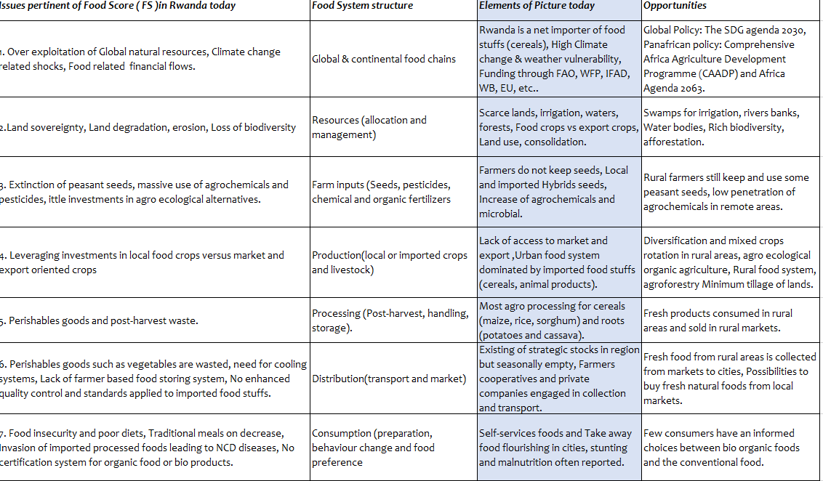Source: Authors, secondary data

3.2. Impact on Food Production
In Rwanda, since the outbreak of COVID-19, different people were affected in the food chain, disrupting supply chain, and hampering trade. Farmers, livestock farmers, food transporters and small and medium agriculture entrepreneurs were all affected by the virus as far as food security is concerned. The study indicated the main challenges in the production including under-developed supply chains with limited private sector investment, leading to accessibility issues and low value addition, limited diversity in production with a focus on priority, staple crops resulting in low production, affordability, and availability of nutrient-rich foods (e.g., vegetables, fruits), poor infrastructure for transportation, storage, and distribution leading to high food losses (9.7% vegetables , 11% fruits , 6.9% cereals), insufficient production and low crop yields (crop production remains at ~45% of potential yield), limited use of agricultural inputs as well as constrained access to finance of farmers, chains with limited private sector investment, leading to accessibility issues and low value addition.
For the Maize, production, the figure below indicates the maize production (in tons) between 2019 and 2020. The COVID-19 has a negative impact on maize production because in February 2020 the production of maize was 353, 999 tones and reduced from February to June 2020 (94.634 tons) resulting in reduced market availabilities and higher food prices as indicated in the figure below. The findings of this study show that there are many farmers and other actors engaged in the maize production. The study analysis indicated that the maize sector has various growth potentials in Rwanda and is considered among the key food security priority crops and there are emerging market potentials with an increasing planting areas and demand of the product (institutional buyers and emerging processors). A study conducted IFPRI in 2021 on Economywide impact of COVID-19 has revealed that agricultural sector was largely exempt from the lockdown restrictions and has affected the sector indirectly via reductions in intermediate demand from many non-agricultural sectors and from reductions in household and export demand. The same study indicated GDP and fall in a 12.6 percent for the broader agri-food system comprising of agriculture, agro-processing, food trade and transport, and food services during the COVID-19 pandemic.

Figure 1: Impact of covid-19 on maize production (tons) in 2020 in Rwanda
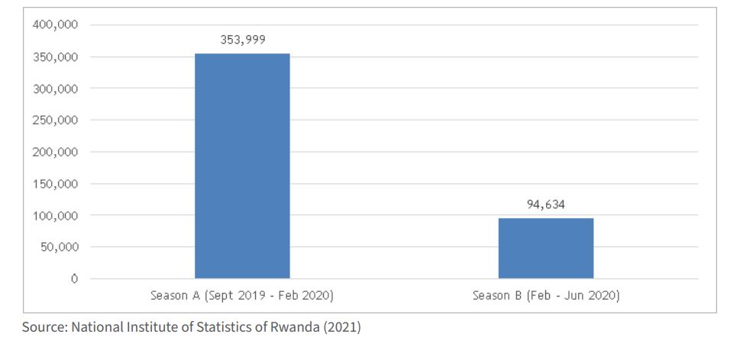
Agricultural exports crops
The Government of Rwanda has prioritized the export crops such as coffee, horticulture-based products, among others. A preliminary assessment suggests that the COVID-19 pandemic may add between 83 and 132 million people to the total number of undernourished in the world in 2020. The same report articulates the critical link between food security and nutrition outcomes: food consumption and diet quality whereby Diet quality comprises four key aspects: variety/diversity, adequacy, moderation, and overall balance.
The data from the survey show that Rwandan coffee firms in 2020 exported less volumes by 35%, however multinational firms and older domestic firms were least affected. The unit price of coffee also rose during the same period, resulting in a smaller reduction in the aggregate value of exports by 18.5% . The relatively stable coffee export revenue in the immediate aftermath of the COVID pandemic reflects a broader resilience of traditional exports compared to other export categories. Data from the National Bank of Rwanda show that the value non-traditional exports and services exports declined by 56.3% and 46.3% respectively. Due restriction, several coffee exporters faced supply- side bottlenecks. A study on Rwanda coffee during COVID-19 period (Dere, et.al, 2021) indicated that during over half of Rwandan coffee firms faced labour shortages during lockdowns and costly international freight charges. Outside Rwanda, dwell times at border crossings and at Mombasa port dramatically increased between March and April 2020 due to heightened pandemic surveillance. The same study indicates that these challenges may have contributed to an increase in operational costs experienced by the majority of surveyed exporters and two thirds of surveyed exporters perceived a significant reduction in their ability to service their loans.
Coffee Exports crops products in Rwanda (2020)
Coffee export quantities and revenues have been fluctuating over the past years. The figure 2 below indicated that there was a decrease in exported quantities, but revenues increased by 1.8% mainly due to increased average prices from $3 per/kg to $3.6 per/kg in 2020 due to Covid-19 pandemic. The main exported coffee types were fully washed coffee (77.85%), Semi washed (10.7%), Triage (5.08%) and Natural (4.24%).
Figure 2: Coffee Exports crops products in Rwanda (2020)
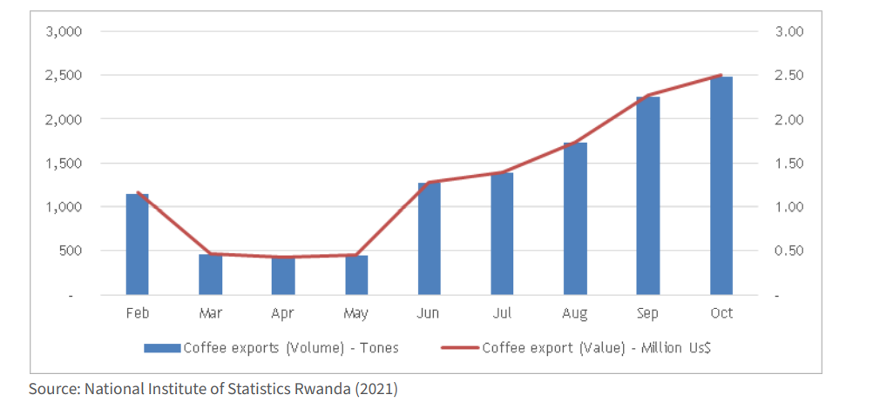
Horticulture
The data from NISR report (SAS 2021A) out of the total recorded production national wide, exported horticulture quantities accounted for 8.5% equivalent to 15,804 MT that generated USD 28.7 million in FY 2020/21. This indicates an increase of 0.3% compared to the revenues generated last fiscal year. This was mainly made up of 13,088 MT of vegetables that generated $13 M, 4,993 MT of fruit that generated $7.7 M, and 1,193.8 MT of Flowers which generated to $7.9 M as indicates in the figure 3.
Figure 3: Rwanda horticulture exports (US$ million) in 2020
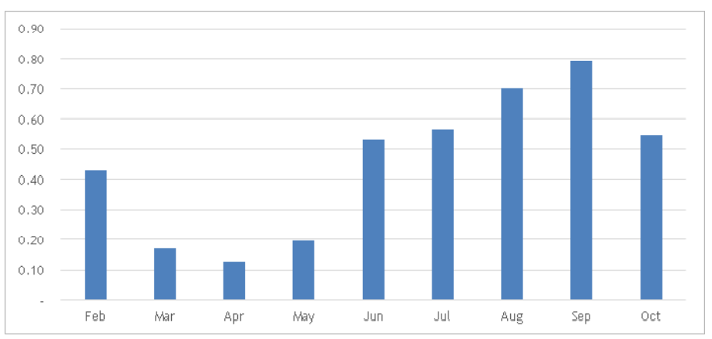
According to the study conducted by Rwanda Women Network in 2020 on the impact of COVID-19 on Women Workers in the horticulture sector in Rwanda showed that employment/farms have been significantly affected with decrease in production and sales by up to 50% on average due to the pandemic. Findings of this study found that horticulture value chain development has enormous business and market opportunities based on consistent and regular supply of vegetables and fruits as well as a high market potential at national, regional and international level for export. There is however a lack of lead market operators like processors. Results of the study indicated that the supply chain for vegetables is very weak due to inconsistent supplies to the markets and lack of basic conditions to improve productivity, lack of postharvest facilities for reducing the losses of products. This may be attributed to the fact that farmers don’t have production capacity to produce the volume and quality of vegetables demanded in the markets. The findings of this study indicate that National Agriculture Export Board (NAEB) and MINAGRI would further perform if the local aggregation for horticulture is in place at proximity of the farms with proper conditioning facilities to reduce postharvest losses. Double efforts would be made to improve input supply chain and aggregation systems in the export sector to make the supply chain more effective, inclusive and more competent. The study revealed that horticulture value chain is overall very weak and less organized with few market actors in some important Value Chain (VC) segments like processing or institutional buyers to pull the market. Analysis of this study indicates that there are several challenges in the horticulture supply chain. These include among others high costs of inputs for smallholder farmers, high post-harvest losses, low quality for local produce leading to low incentives in terms of local market prices and risk of rejection of a big portion of the volume supplied.
Input Suppliers. The figure 4 below shows that the overall prices of inputs (Some inorganic fertilizers and maize seeds) have increased from 2017 to 2022 (for example, price of NPK 17 17 17 was 520 Rwf in 2017 and is 882 in 2022 without government subsidies) due to different causes such reduction in input imports, difficulty in distributing up country (for agro-input dealers), lack of visibility on forecast market prices (for aggregators, traders, and cooperatives) and issues in the changes of the regulations on movement within and across borders and other services.
Figure 4: Prices of some agricultural inputs in Rwandan francs
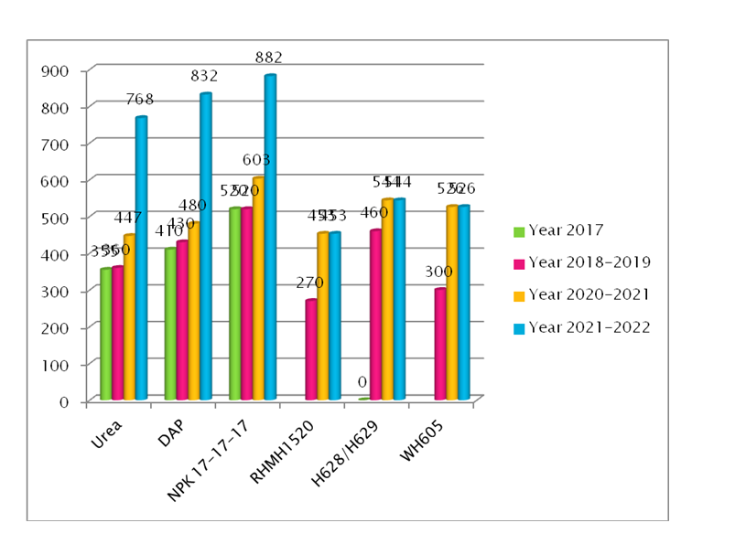

3.3. Impact of COVID-19 on food transformation
Using data extracted via the FAOSTAT data Price Monitor from to estimate cost of living in Rwanda, the figure below indicated that the average price changes across 4 main food products. Specifically, for avocados from 287(2018) to 301 (2020) and Potatoes 259(2019) and 2020(330 USD).
Figure 6: Average Changes in Food Prices (USD) since the Start of COVID-19 2019 to 2020

The COVID-19 pandemic has affected all people in the food supply chain in Rwanda as well as the food security of the country. In Rwanda since the outbreak of COVID-19, it affected different people in the food chain, disrupting supply chain, and hampering trade. Farmers, livestock farmers, food transporters and small and medium agriculture entrepreneurs were all affected by the virus as far as food security is concerned. study indicate that changing in price due to the market access, logistical problems related to transportation and border restrictions which lead to lower supplies, access, and consumption and has affected buyers and processors, small rural traders (their relations are ad-hoc based-on business opportunities. The study conducted by FAO, (2020) reported that in the East African Community (EAC) region, the food gap due to COVID-19 was 13.5% higher for 2020, and the region needed 338 metric tonnes (MT) of grains to meet this deficit, vis-à-vis regional production of 55.4 million tonnes. A report conducted by GAIN, 2020 indicated that the demand for staple foods and non-perishable products has increased and specifically the demand for horticultural produce which has fallen due to the consumer preferences for staple foods and non-perishable products that can be stockpiled. The same report indicated that after the lockdown, most of the households reliant on horticulture for income have experienced a reduction in their incomes and may needed to cut expenditures on food, education, and/or health. A study conducted by Rwigema Pierre Celestin on impact of COVID-19 on lowdown food security in Rwanda indicated that the COVID-19 crisis in Rwanda has exponentially increased Rwanda’s food security problems where the access to food supply chain distribution networks were severely constrained. The same study indicate that 95% of respondents indicated income decline and 88% reported being food insecure, three quarters of respondents cooked less frequently and half altered their diet, one quarter (27%) of households primarily using Liquefied Petroleum Gas (LPG) for cooking before lockdown switched to kerosene (14%) or wood (13%). A total values in export for avocados in Rwanda were US$ 32, US$ 1,664, US$ 4,112 and US$ 9,936 in US dollar thousand for the years 2016, 2017, 2018 and 2019 in that order. A study conducted by IPA, 2020 on RECOVER survey indicates that, due to COVID-19, the increase of poverty income insecurity was reported and almost 80% of the respondents have gone through their savings to cover basic needs, 50% of the respondents had to decrease their food consumption, 10% of the respondents stated they had received food or reduction in utility charges from the government 25% stated they had experienced difficulty with buying food due to restrictions on mobility and market closures. The same report shows that rural citizens are more likely to experience difficulty buying food than urban citizens. Food insecurity has increased whilst farmers have been embedded in a market-oriented system in which they have little bargaining power (Ansoms, 2020). Furthermore, the increasing food insecurity in rural areas raises questions about the resilience of farmers in the face of COVID-19, especially as government support has only targeted urban areas. A study conducted by Duncan Kayiira (2020) reported that in 2020 estimate of food insecurity for five of the six partner States of the EAC region was 2% to 5% higher than the pre-COVID-19 scenario. A study conducted by IFPRI, 2021 on prices changes of staples foods month-by-month between August 2019 and August 2021 in Rwanda indicated that the prices increased considerably during the months leading up to the pandemic. The report shows that from August 2019 and January 2020 no changes was observed, prices of staple foods did not increase by more than one percent above the February 2020 base period and, in fact, have been continuously decreasing since October 2020 and this were hardly affected by the pandemic in Rwanda. The same report indicate that the prices of pulses were somewhat higher during the end of the calendar year in 2020 as compared to the same period in 2019. A study conducted by IFPRI, 2021 on food system in Rwanda indicated that 80% of premium maize is imported, depriving local farmers from income and driving up import reliance. Due to COVID-19, most of the products, a loss and waste lowers environmental impact of production and avails more food for domestic consumption were increased. Because of safety and quality concerns of losses of products, there is need to put in place better infrastructure by minimizing losses & maintains quality of food and stronger postharvest handling capacity (including drying grounds, silos and cold chain) and skill to reduce losses (e.g., from aflatoxin, pests). The study indicate that they are still low private investment in building and maintenance of post-harvest infrastructure and services and inefficient supply chain of food production. There is a need to invest in improving aggregation system by attracting professional aggregators in the high production sites, invest in proper conditioning facilities at the proximity of the farms to cut off transport cost but also keep the quality standards of produce after harvest, and invest in new farming technologies for smallholder farmers with high potential of market demand ( if they have a guaranteed markets with attractive prices).

3.4. Strategies for response and mitigation.
To support the vulnerable groups in Rwanda, the Government has established the Local Administrative Entities Development Agency (LODA), any agency that supports districts on Local Economic & Community Development, Social Protection. In addition, the presence of the Rwanda Local Development Support Fund (RLDSF) which provides financial support to local government development activities, i.e. financing the development projects focusing on infrastructure, reduction of extreme poverty among the poorest people through Vision Umurenge Program (VUP). To minimize the impact of restrictions, Government has established the Economic Recovery plan to support activities affected by COVID-19. The government of Rwanda rolled out a food relief program in July, 2021 distributing rice, maize, and beans to 211,000 vulnerable households in areas under lockdown. Government promised to inject Rwf 100 billion to start a coronavirus (Covid-19) exit process and counteract the impact of the pandemic on the economy, the funding used to support agriculture and livestock activities. Food distribution to support vulnerable families who had been affected by the lockdown. Food was sourced from the National Strategic Grain Reserve managed by the Ministry of Agriculture and Animal Resources. Local village leaders have for instance been activated to compile lists of vulnerable people for targeting food distribution. Through its National Strategic Grain Reserves Project, the Government registered storage of 21,302 MT of food staples, composed of 15,571 MT of maize, 181.154 MT of rice and 5,550 MT of beans. MINAGRI annually report (2020-2021) indicated that from this reserve, 3,796.46 MT of Maize 1,475 MT of beans and 181.154MT of rice have been distributed to the families affected by disaster and lockdown due to Covid-19). Fixed prices for selected essential food consumed by most people like maize, beans, bananas, sugar, rice, cooking oil among others. However, more than 50% of respondents of a RECOVR survey (2020) stated to have reduced food consumption due to a decrease in income. The government of Rwanda has supported vulnerable families who have been affected by the lockdown with the intention to curb the spread of the virus. The intervention has started in some parts of the three (3) districts of Kigali. The supports include foods and other essential products. The cities were prioritized because they are most likely to be affected by the lockdown. The Government also made significant efforts to continuously address national food and nutrition security during 2020/21 FY, especially as a response to the effects of the ongoing COVID-19 pandemic.

3. CONCLUSIONS AND RECOMMENDATIONS
The study has indicated that due to COVID-19, farmers have an overall limited access to inputs including chemical fertilizers and seeds, costs and long distance for farmers to reach the nearest suppliers which they are importing from outside countries. This study has found significant changes in food price due to COVID-19 and affected the consumption behaviour of communities. Furthermore, the findings of the study indicate that the Government of Rwanda has established some measures to the response of COVID-19 including minimize the impact of restrictions, the government of Rwanda rolled out a food relief program in July, 2021 distributing rice, maize, and beans to 211,000 vulnerable households in areas under lockdown and inject Rwf 100 billion to start a coronavirus (Covid-19) exit process and counteract the impact of the pandemic on the economy, the funding used to support agriculture and livestock activities and good distribution to support vulnerable families who had been affected by the lockdown. The findings also indicate that increasing food insecurity in rural areas raises questions about the resilience of farmers in the face of COVID-19, especially as government support has only targeted urban areas. There is a need to introduce new agriculture technologies for farmers with high potential to increase productivity; and stimulate collective action for actors in agriculture including collective purchase of inputs. More Strategies that support farmers to overcome to crisis and pandemic. Efforts should be aimed at increasing production and promoting usage of fertilizers from locally and adoption of modern farming technologies in local context and not expecting to import most of the agricultural inputs. Exploiting Regional Trade Opportunities - Rwandan exports crops can be produced at a price that is competitive in neighbouring markets. The main hurdle to increased export trade is building the cross border markets and improve trade networks into neighbouring markets of Burundi, DRC, Tanzania, and Uganda. Partners in food production and consumption should also invest in capacity-building of farmers and build integrated consultation processes to crowd source the expertise, provide technical expertise, knowledge, and capacity innovation on food production and consumption in Rwanda. Additionally, emphasis should be placed on protecting supply chains from any form of disruptions in the short term. This is especially so with the current partial lockdown, there is also need for facilitated inter county and inter country border crossing through a coordinated approach of testing and social distancing measures to ensure free flow of staple food commodities. The study concludes that the pandemics largely impacts on food security and nutrition. Therefore, it is necessary to ensure sustainability of resources, strengthen infrastructure and food systems to avoid or minimize food crises in the future. Governments need to put measures geared towards promoting smallholder farming, which accounts for the highest percentage of production for developing countries, such as accelerating e-commerce platforms connecting farmers and consumers. Sustainable, resilient food systems need to be established to boost food safety and minimize transmission of pathogens. This will also reduce future food and health crises worldwide. One of the key ways in which the Rwandan economy can build resilience to mitigate and manage shocks is to create buffers with one vital safeguard being strategic food reserves. Food reserves are required as a buffer to support adjustment in times of drought and subsequent famines that put pressure on fiscal reserves, as well as for other crisis situations such as the current COVID-19 pandemic. The government should also decide whether to reconsider biotech seeds, which might provide greater resilience against climate and pest threats to improve the overall health of the system in the longer term. Due to low safety and quality concerns of losses of products, there is need to put in place better infrastructure by minimizing losses & maintains quality of food and stronger postharvest handling capacity (including drying grounds, silos and cold chain) and skill to reduce losses.

REFERENCES.

- Assessing market price dynamics during the COVID-19 pandemic in Rwanda, 2021
- Circular Economy in Africa: EU cooperation: Country Report for Rwanda. Whyte, C. R. ; et al. (2020).
- Derek Apell1 & Ameet Morjaria. Rwandan coffee exports during COVID-19, International Policy Centre (IPC), Policy Brief, 2021
- Duncan Kayiira, 2021. Impact of COVID-19 on Agriculture and Food Security in the East African Community. Working Paper - COVID-19_009
- FAO 2016).
- FAO Food Balance Sheets, 2018
- FAO Food Balance Sheets, 2018
- FAO Food Balance Sheets, 2017
- IFPRI, 2021, Diagnostic and Landscaping Analysis by the Food System Transformative Integrated Policy (FS-TIP) Initiative
- IFPRI, Research Journal of Business Management, 2021. Impact of Covid-19 Lockdown on Food Security in Rwanda
- GAIN. 2020. Impact of COVID-19 on Food Systems: A Situation Report, Edition 4. November 23, 2020
- Global Panel on Agriculture and Food Systems for Nutrition 2016, HLPE 2017).
- MAMO Panel Report 2021
- Martin Luther Munu and Zjos Vlaminck, 2021. Beyond the curve: equity in Rwanda’s COVID-19 response
- MINAGRI, 2017
- MINAGRI, Fourth Strategic Plan for the Agriculture Transformation 2018-2024
- MINAGRI, 2017 - 2021. Amabwiriza ya Minisitiri w’ubuhinzi n’ubworozi yerekeranye n’itangwa ry’inyongeramusaruro zo mu buhinzi. Kigali Rwanda
- MINAGRI Annual report 2020/2021
- National Strategy for Transformation(NST1)
- National Institute of Statistics of Rwanda, Seasonal Agricultural Survey (2019, 2020 and 2021). Kigali
- Rwanda Food system transformation diagnostic report, 2021
- Strategic Plan for Agriculture Transformation
- Women Network 2020. Impact of COVID-19 on Women Workers in the Horticulture Sector in Rwanda

Additional link of documents

- https://www.selinawamucii.com/insights/prices/rwanda/avocados/

- .http://www.fao.org/3/ca9692en/online/ca9692en.html

- https://www.minagri.gov.rw/updates/news-details/rwanda-on-good-track-in-implementing-the-continental-comprehensive-africa-agriculture-development-programme

- https://www.sciencedirect.com/topics/computer-science/food-consumption

- https://tradingeconomics.com/rwanda/imports/cereals#:~:text=Rwanda%20Imports.

- https:// / www.wfp.org/countries Rwanda

- https://www.aakash.ac.in/important-concepts/biology/food-production.

- https://www.sciencedirect.com/topics/social-sciences/food-production

National Strategy for Transformation(NST1)
Strategic Plan for Agriculture Transformation
https://www.minagri.gov.rw/updates/news-details/rwanda-on-good-track-in-implementing-the-continental-comprehensive-africa-agriculture-development-programme
https://tradingeconomics.com/rwanda/imports/cereals#:~:text=Rwanda%20Imports.
https:// / www.wfp.org/countries Rwanda
Rwanda Food system transformation diagnostic report, 2021
MINAGRI, 2017
https://www.aakash.ac.in/important-concepts/biology/food-production.
https://www.sciencedirect.com/topics/social-sciences/food-production
Circular Economy in Africa: EU cooperation: Country Report for Rwanda. Whyte, C. R. ; et al. (2020).
https://www.sciencedirect.com/topics/computer-science/food-consumption
MINAGRI,Fourth Strategic Plan for the Agriculture Transformation 2018-2024
FAO 2016).
(Global Panel on Agriculture and Food Systems for Nutrition 2016, HLPE 2017).
FAO Food Balance Sheets, 2018
FAO Food Balance Sheets, 2018
FAO Food Balance Sheets, 2017
MAMO Panel Report 2021
MINAGRI, 2021. Annually report
http://www.fao.org/3/ca9692en/online/ca9692en.html
Women Network 2020. Impact of COVID-19 on Women Workers in the Horticulture Sector in Rwanda
Rwandan coffee exports during COVID-19, International Policy Centre (IPC), Policy Brief, 2021
National Institute of Statistics of Rwanda, Seasonal Agricultural Survey (2019, 2020 and 2021). Kigali
Women Network 2020. Impact of COVID-19 on Women Workers in the Horticulture Sector in Rwanda
MINAGRI, 2017 - 2021. Amabwiriza ya Minisitiri w’ubuhinzi n’ubworozi yerekeranye n’itangwa ry’inyongeramusaruro zo mu buhinzi. Kigali Rwanda
GAIN. 2020. Impact of COVID-19 on Food Systems: A Situation Report, Edition 4. November 23, 2020
IFPRI, Research Journal of Business Management, 2021. Impact of Covid-19 Lockdown on Food Security in Rwanda.
https://www.selinawamucii.com/insights/prices/rwanda/avocados/
Martin Luther Munu and Zjos Vlaminck, 2021. Beyond the curve: equity in Rwanda’s COVID-19 response
Assessing market price dynamics during the COVID-19 pandemic in Rwanda, 2021
IFPRI, 2021, Diagnostic and Landscaping Analysis by the Food System Transformative Integrated Policy (FS-TIP) Initiative.
Martin Luther Munu and Zjos Vlaminck, 2021. Beyond the curve: equity in Rwanda’s COVID-19 response.

