Call for application

Professional Training on “Project Management for Donor Funded Projects”

Course Code: EPRN09/PT/22

- DATES: 25th -28th January 2022 (5h30pm to 8h30pm)
- VENUE: University of Rwanda-CBE Gikondo Campus
- Fees: 60,000 Rwf (EPRN members); 100,000 Rwf (non-members)
- COVID-19: All participants must have a negative covid-19 test to be allowed into training room.

1. Introduction

This course is very hands-on and interactive, thus providing a step by step approach to project design, implementation, monitoring and impacts evaluation. An analysis of all the different phases of the project/programme cycle will be carried out to emphasis the methodology for preparing, implementing and evaluating projects and programs. Particular effort will be made to bring clarity to the terminology used by the donors’/development partners for the different stages for the project/programme cycle, and the course will be more of practical.

2. Course content

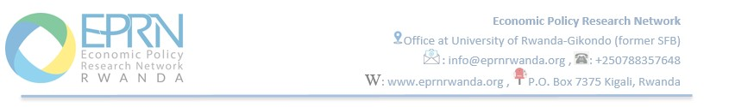
The content of this course include (and will mostly involve practices):

- Programming, which is the first phase of the project/programme cycle will involve an analysis of the process of setting broad national/regional/ sector policy objectives at the global/overall level.
- Following on from programming, the various techniques used in the Identification of projects/programs from the prioritized list of overall objectives will be explored in the second phase of the project cycle i.e. Identification.
- The third phase of the project cycle, Formulation will focus on designing and developing the concept of the project/programme and testing its logic and feasibility i.e. technically, socially and environmentally.
- In the fourth phase of Financing, the contractual obligations between the funding agency i.e. the Contracting Authority and the Implementing Agency/party will be examined.
- The Implementation Phase will involve outlining the stages of implementation with emphasis on what needs to happen in the three important stages of (i) Inception (2) Operational and (3) Phase out. The Principles of Monitoring will be discussed as well as how to design a monitoring system.
- The Evaluation Phase will analyze the 5 main Evaluation criteria used by the major Donor/Development Partners (Relevance, Effectiveness, Efficiency, Impact and sustainability). The rationale as to why different Donors/Development partners use more or less than 6 phases in their project/programme cycle will be explained.

3. Training methods

The training course will be run in a workshop style with a high degree of participants’ involvement. Adult learning methodologies will be employed, and participants will not be passive. Debate and open discussions will be encouraged. The trainer will use a mix of presentations to define and explain key concepts and practical exercises (including real case studies). The training is online and we will share a Link and Course Materials, ahead of training date to paid-up trainees.

4. Certificate

EPRN will issue completion certificates to participants who will successfully attend the course and pass the course test.
Note: At the end of the course, the trainer will deliver a test, and ONLY participants who will get at least 60% will get the certificates. Others will be advised to wait until another training opportunity for the same course and will attend it free of charge (this chance is provided only once).

5. Training Fees

- Members: 60,000 Rwf
- Non-members: 100,000 Rwf

6. Payment process

Interested applicants are encouraged to pay the registration fees through the following bank details:
- Bank Account: 00040 06945750 07 RWF (Bank of Kigali)
- Title of the Account: Economic Policy Research Network

Scan the bank slip and send it to: info@eprnrwanda.org and copy to: ed@eprnrwanda.org.
You can also pay through MTN MOMO PAY (*182*8*1*030683#) or through PayPal on our website (www.eprnrwanda.org) and notify us through info@eprnrwanda.org
NB: Tailor-Made Course

We can also do this as tailor-made course to meet organization-wide needs.

Done at Kigali, 19/01/2022
